

First Touch Program

Play skillfully and shout for joy!

Psalm 33:3
Table of Contents

Introduction………………………………………5
Level 1 Getting Started………………………….7
Level 2 Beginning…………………………….…13
Level 3 From a Lift……………………………...17
Level 4 On the Ground…………………………21
Level 5 Intermediate……………………………25
Level 6 With a Twist……………………………27
Level 7 Advanced……………………………….31
Level 8 Stalls and Traps……………………….35
Level 9 Spinning………………………………...41
Level 10 Joggling……………………………….45
Level 11 Speed Juggling……………………….49
Level 12 Bag O’ Tricks…………………………53
Lifts……………………………………………….55
Juggling World Records………………………...56

A Smithway Soccer Book/ Copyright September 2013, 2016

All rights reserved.

No part of this book may be transmitted, reproduced or photocopied by any means, electronic, mechanical or otherwise, without the express written consent of Smithway Soccer.

The greatest mistake you can make in life is to be continually fearing you will make one.

~Elbert Hubbard
Smithway Soccer
First Touch program

In 1958 a 17-year-old boy was playing for Brazil in the World Cup Finals. A cross was played to him on the penalty spot. With a man hanging on his back and another defender closing quickly, he took the ball out of the air on his chest. As the ball started to drop towards the ground, the second defender saw his chance and closed the boy. Before the ball hit the ground the boy juggled the ball over the defender’s head, ran around him, and volleyed the ball into the back of the net! That boy was Pele, and an artist was revealed to the world.

Juggling is your FIRST TOUCH. Every touch you take needs to be placed where, when, and with the exact pace and spin you want. It is not about how many times you can just keep it alive, it’s about control and developing a feel for the ball and making it do what you want.

Pele only took 2 juggles on that goal, but they were exactly where he wanted them to be. He controlled the ball and did not let the ball decide what he should do.

So we are going to learn how to move the ball where we want it, not just keep it up. Having a juggling record is a good overall goal to have to measure improvement, concentration, and endurance but it is not the best way to develop a well-rounded FIRST TOUCH. We will use setting a new record at the end of each level only to help mark your progress.

The FIRST TOUCH program is based on surfaces and putting those in a specific order. Accomplishing the sequences will develop control with all surfaces and the ability to be confident when receiving a ball from anywhere, at any height, with any surface.

This program is for a complete beginner to juggling, as well as an advanced juggler. The beginners will feel a sense of accomplishment as they learn the fundamentals. The advanced jugglers will find that there are holes in their foundation that can be quickly plugged before advancing to the more complicated sequences. I strongly recommend doing every sequence from the beginning no matter what level you believe you are at. There is always room for improvement.

The first sequences are built to start from the laces on the foot. If you cannot start the ball from the ground, you may start from your hands. However, you need to begin practicing LIFTS to be able to start the ball from the ground. I have included a section with some basic lifts at the end of the book (page 55).

A LIFT is any method of getting the ball into the air so you can juggle without using your hands. Starting in Level 3 you will not be allowed to use your hands to start the ball.

You can’t use your hands in soccer, so it’s best to train your feet to do the work at every opportunity.

If you can start the ball from the ground, do so!

Again, make sure you can accomplish each sequence in a level before advancing. Some sequences will come easier than others, but keep working hard and you too will be an artist.

Play Skillfully and Enjoy!!
"Five days shalt thou labour, as the Bible says. The seventh day is the Lord thy God's. The sixth day is for football" – Anthony Burgess
Level 1

Getting Started

- When you get started on level 1, just try to hit the ball with each of the surfaces and catch it with your hands.

- Then, have the ball bounce off the ground and juggle with the correct surface.

- Now that you are comfortable with each of the surfaces, start your program getting 2 juggles on each surface.

Beginners, I recommend juggling on a hard surface to insure a good bounce when starting out. Using the chart on the next page, check off when you have done each part of the level. It is only necessary to do them from the hands and off the bounce to complete the first level. Advanced players should strive to complete it from the ground, however.

If you’re having trouble with a surface, check the pictures on the next page to give you a good idea what it should look like.
Laces Juggle

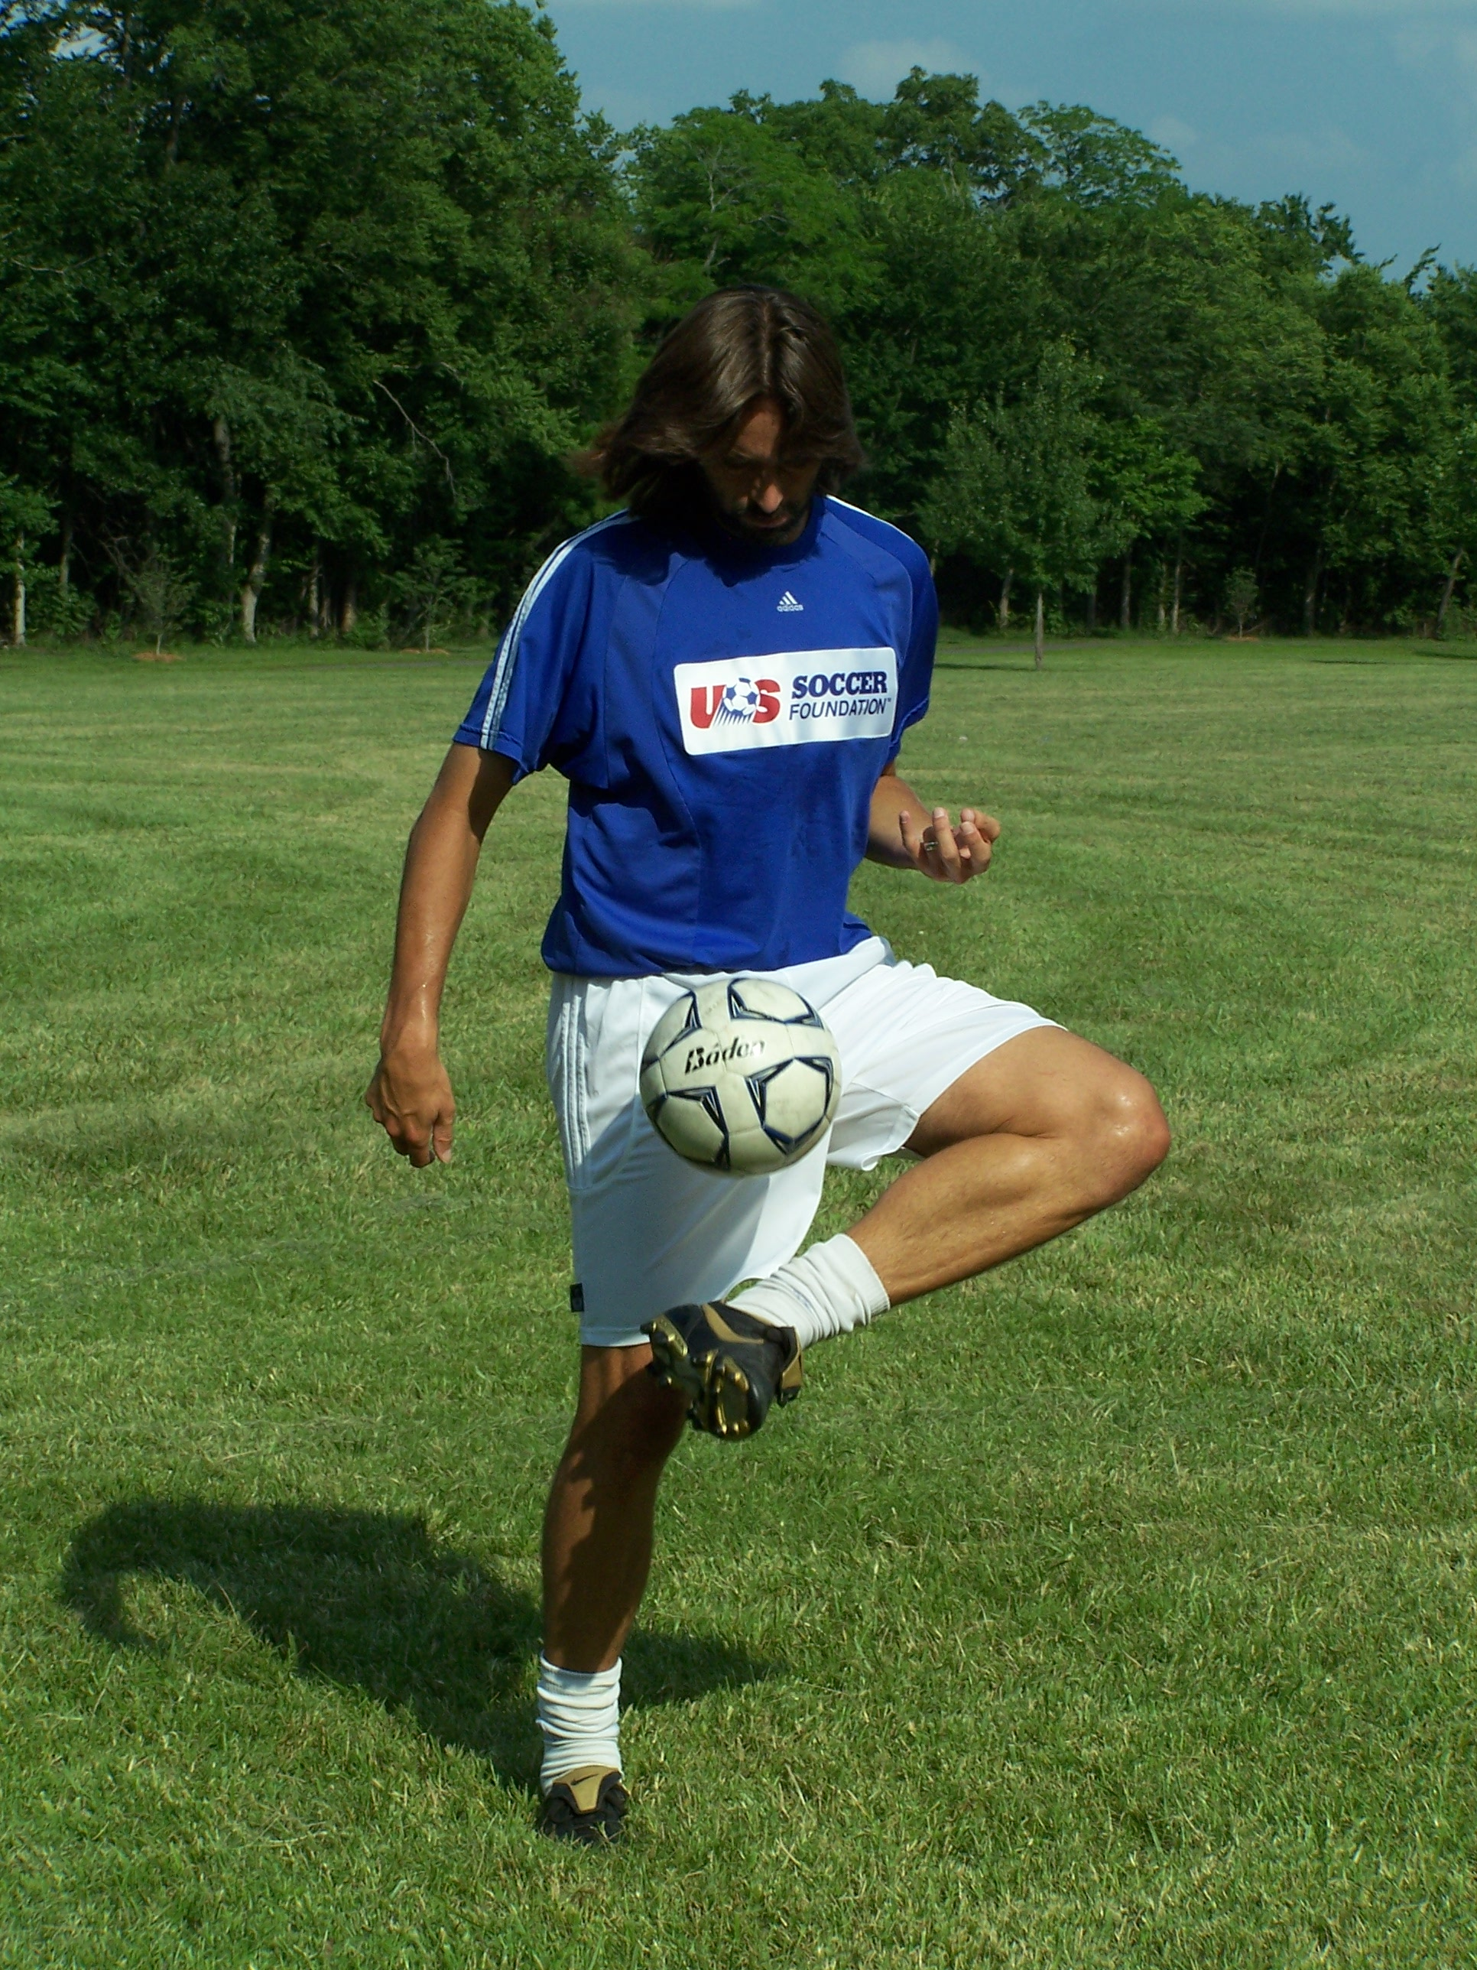
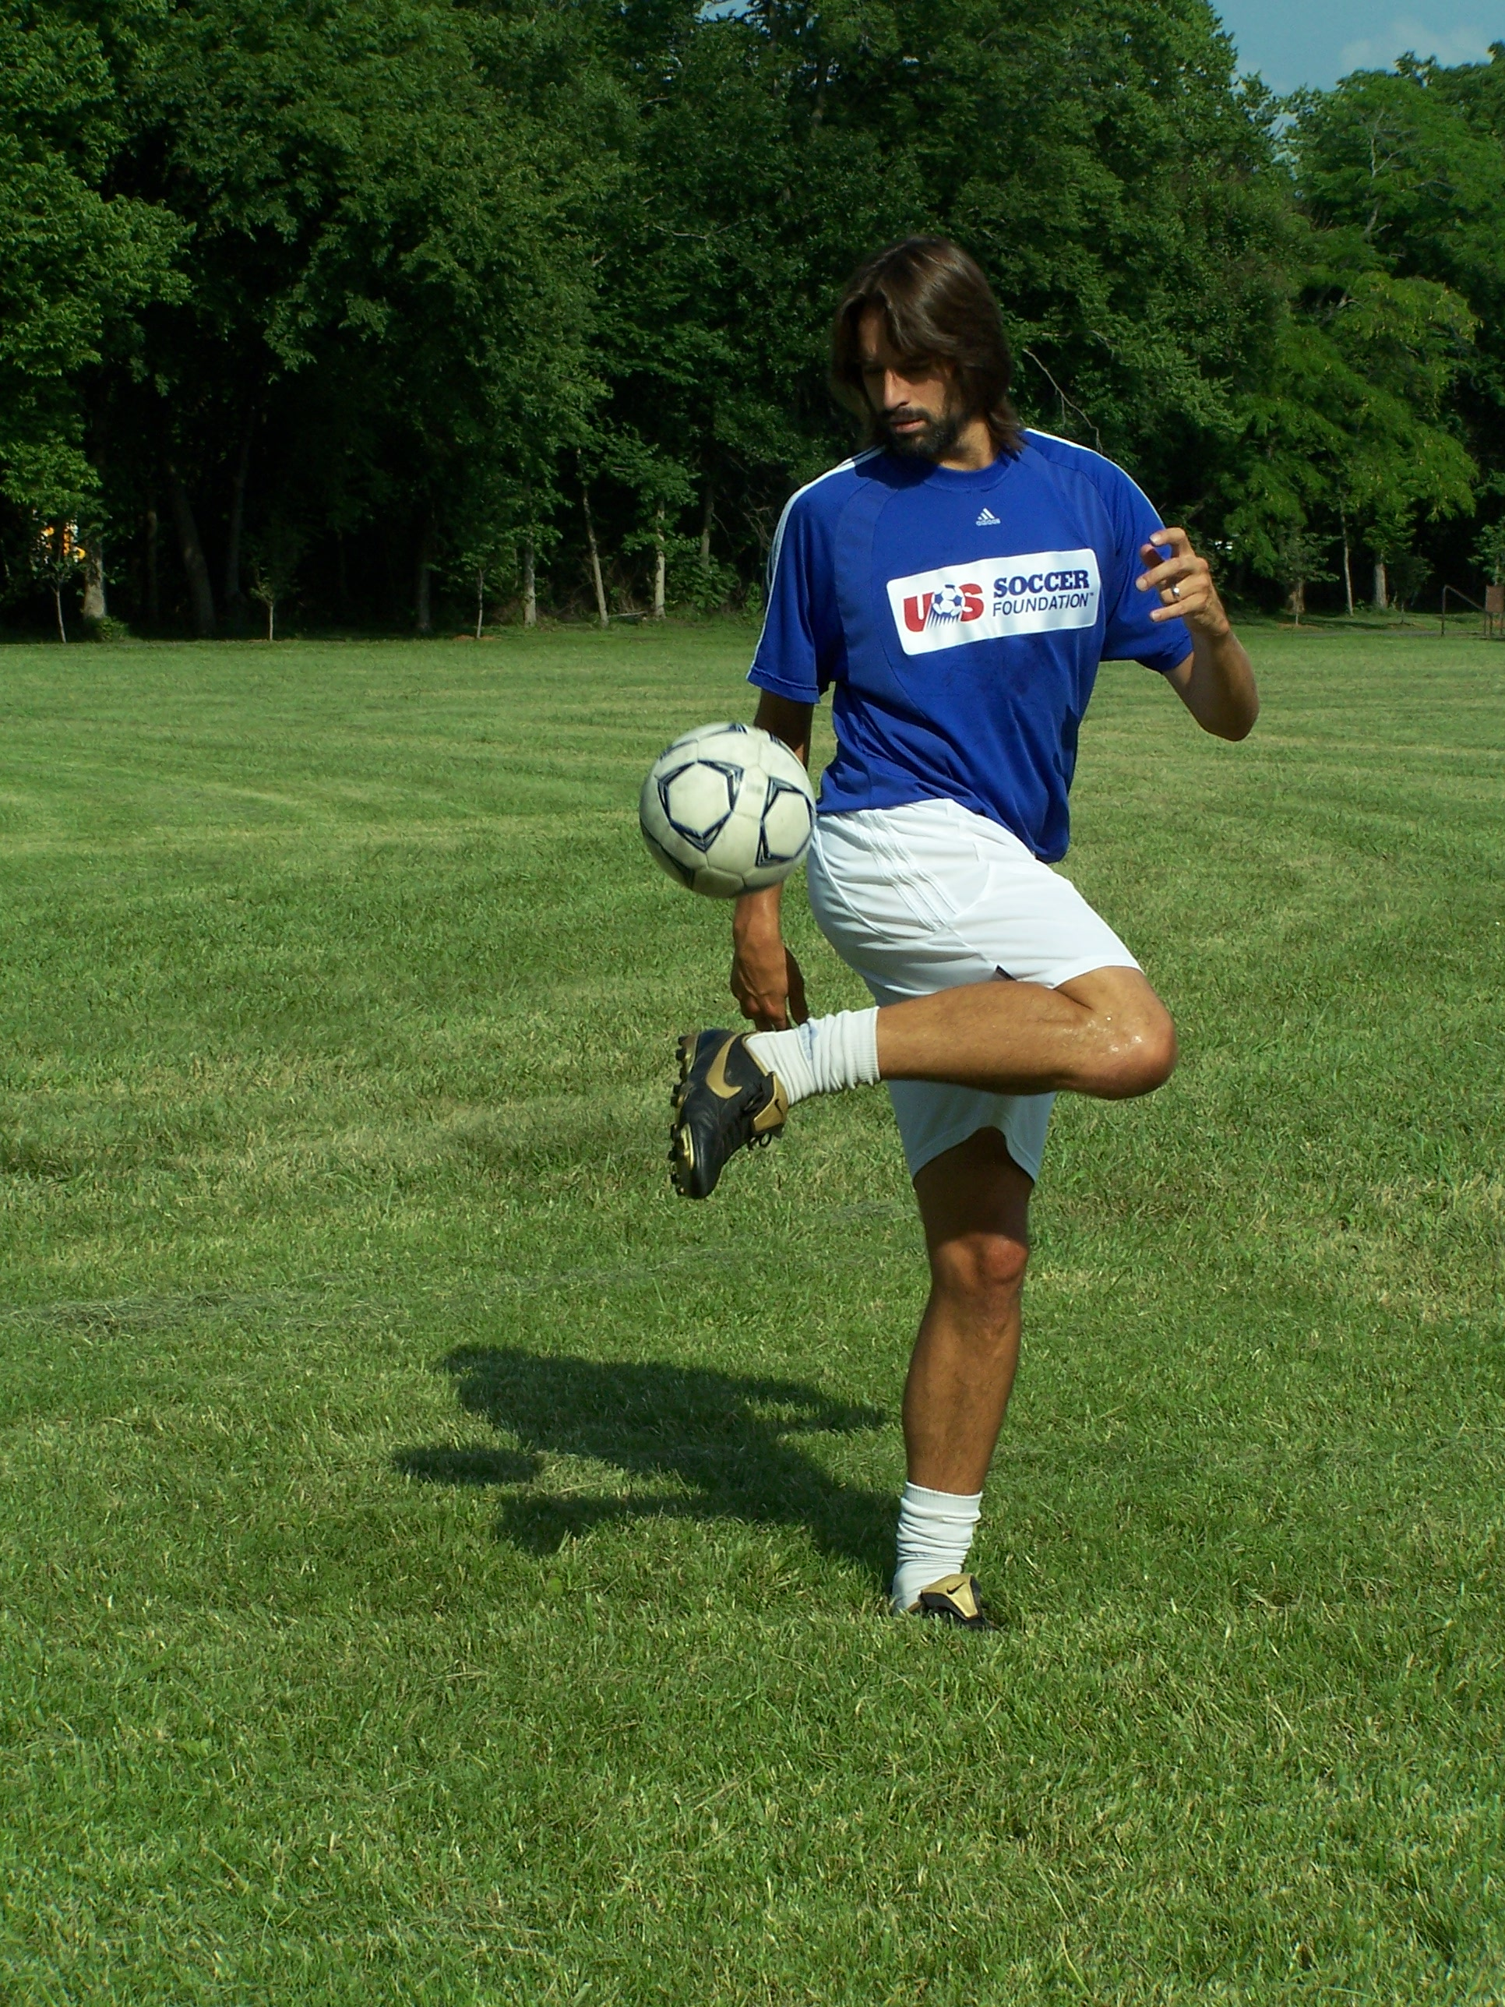
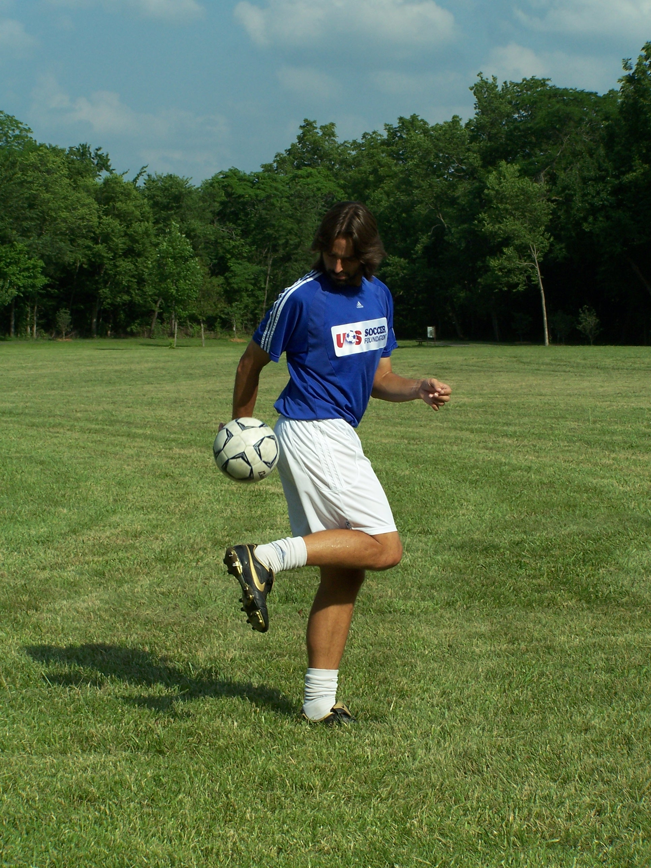
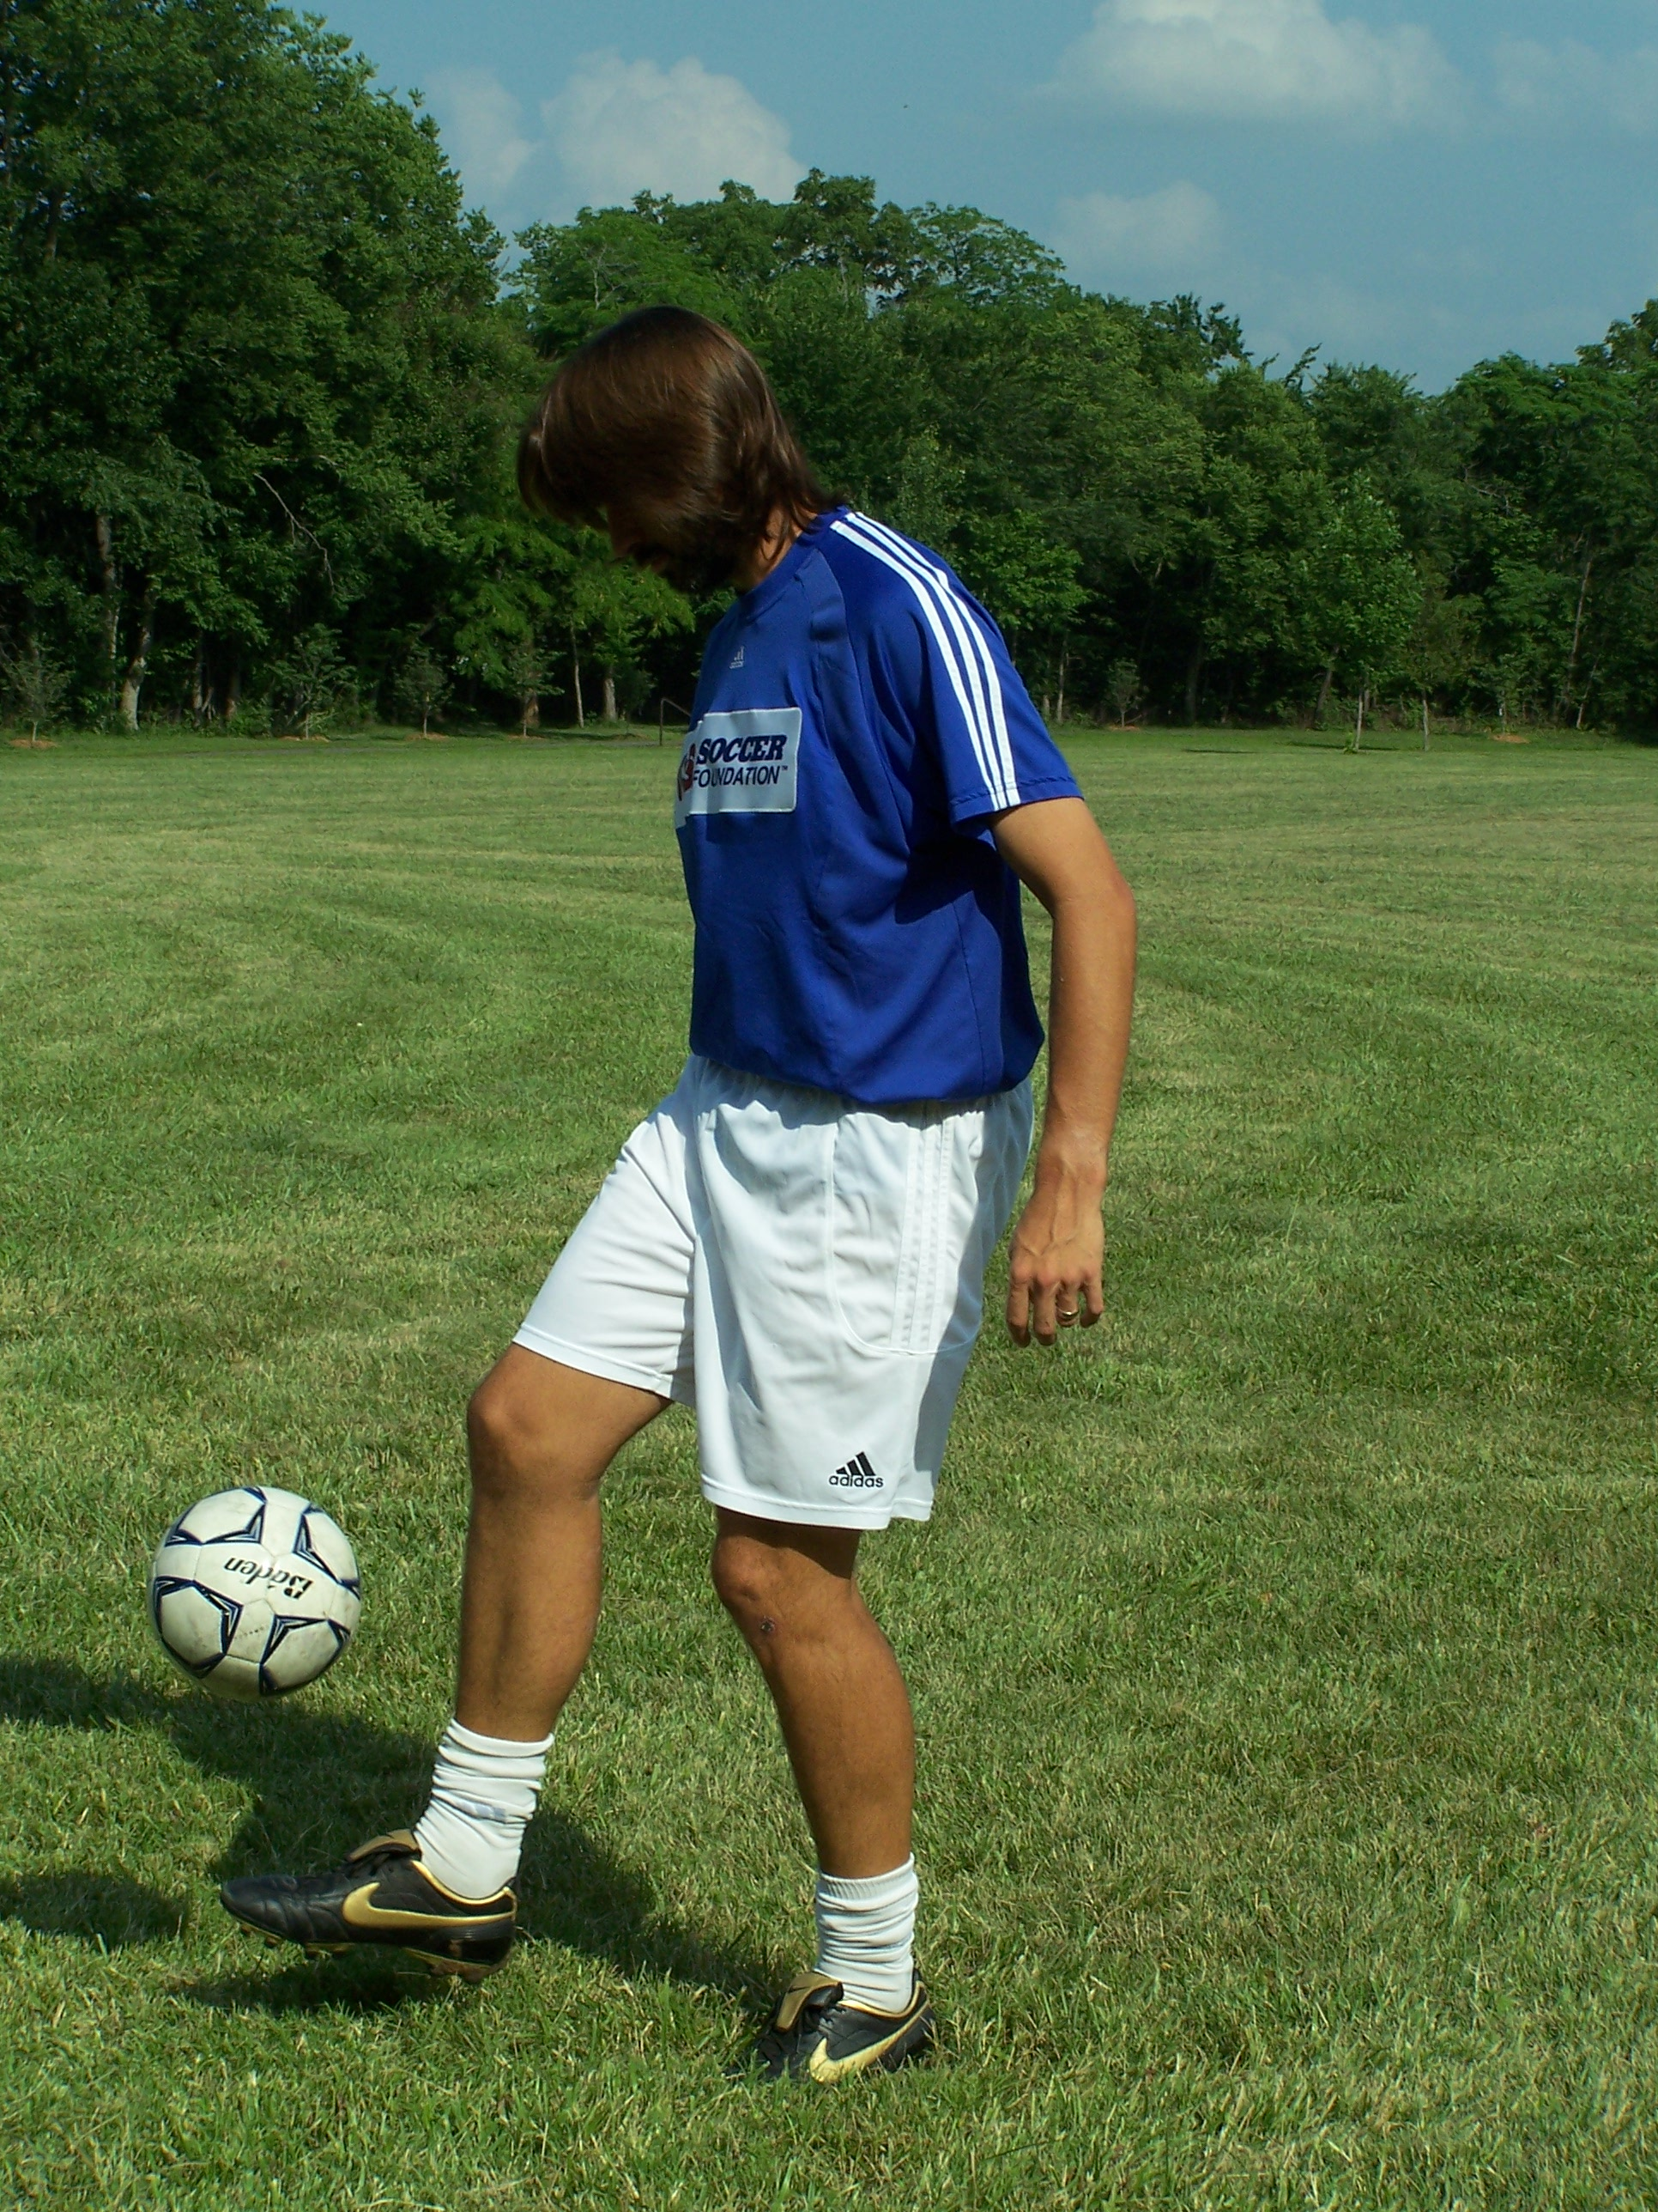

Heel Juggle

Outside of the foot Juggle

Inside of the foot Juggle

Chest Juggle

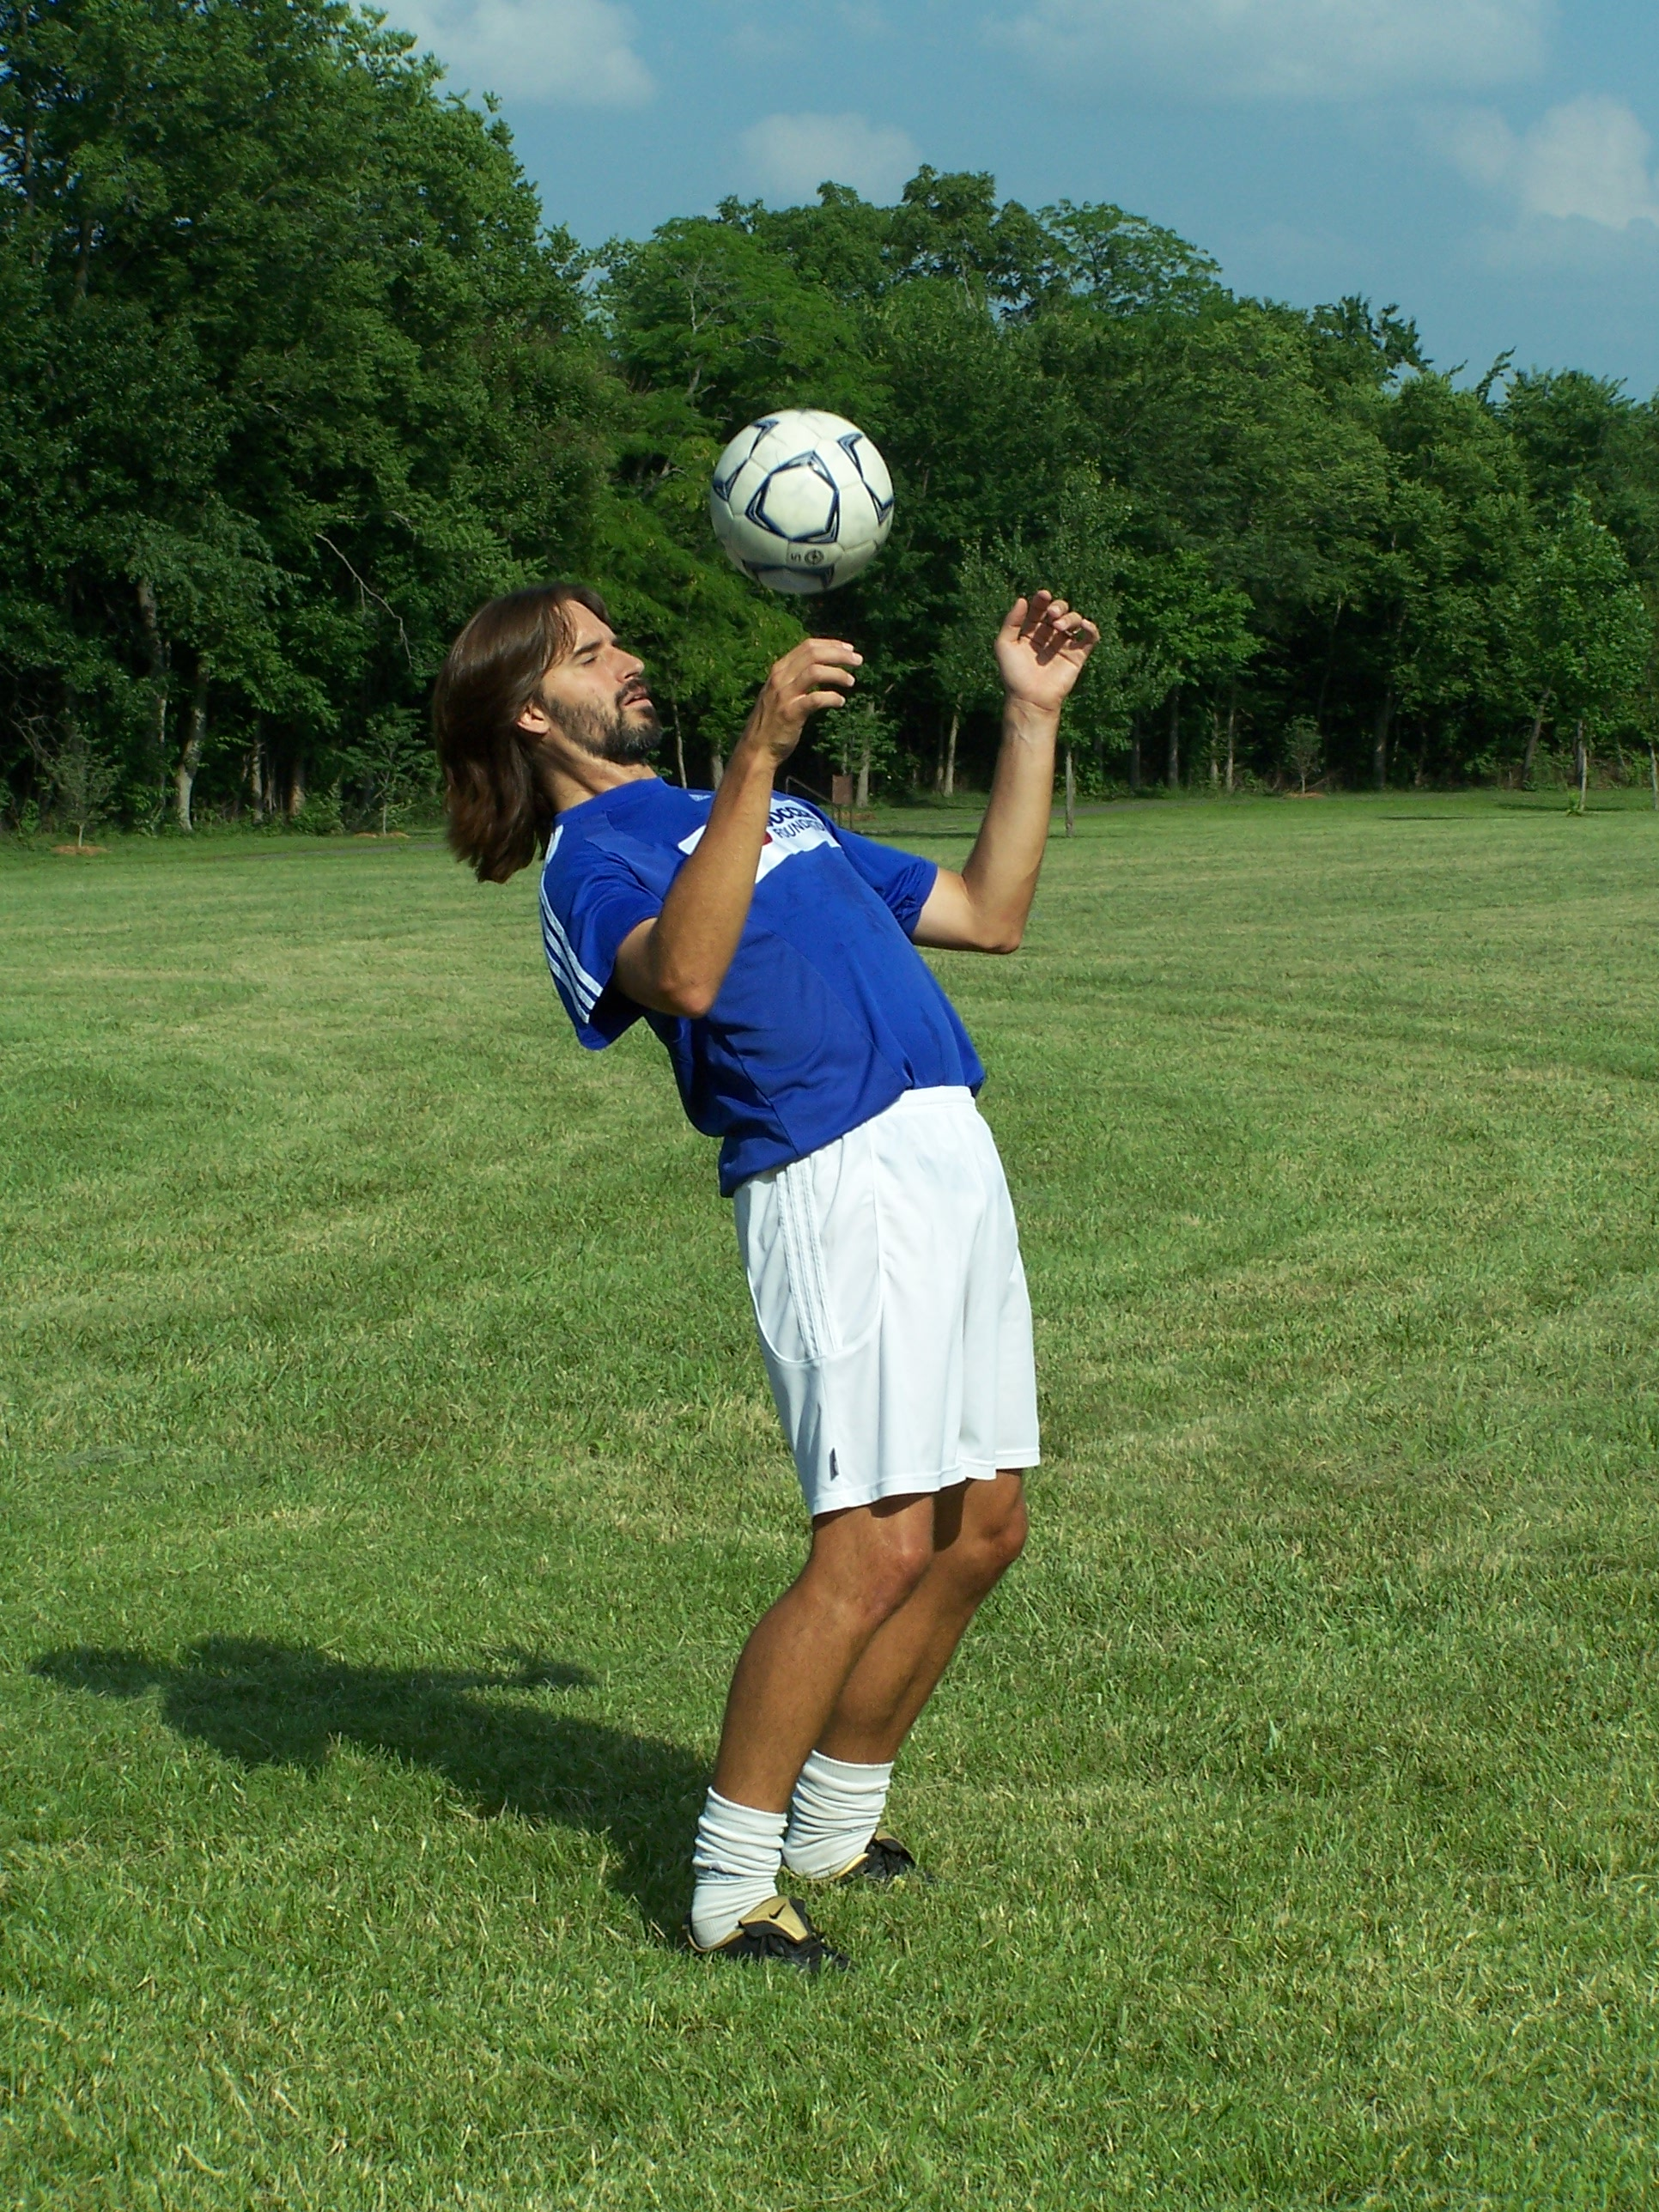
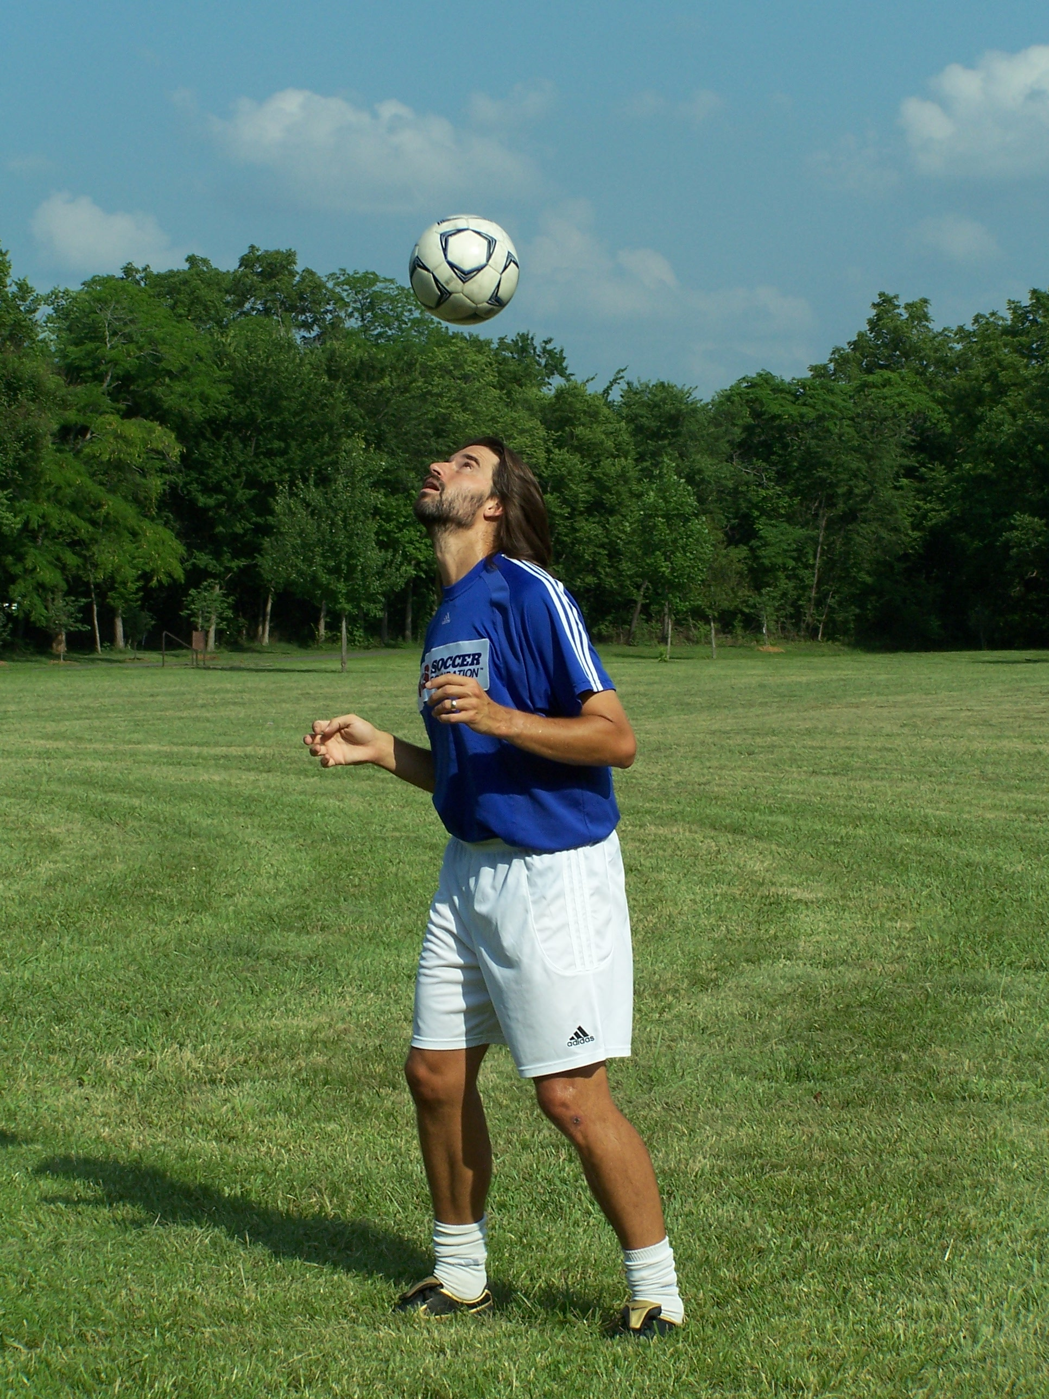
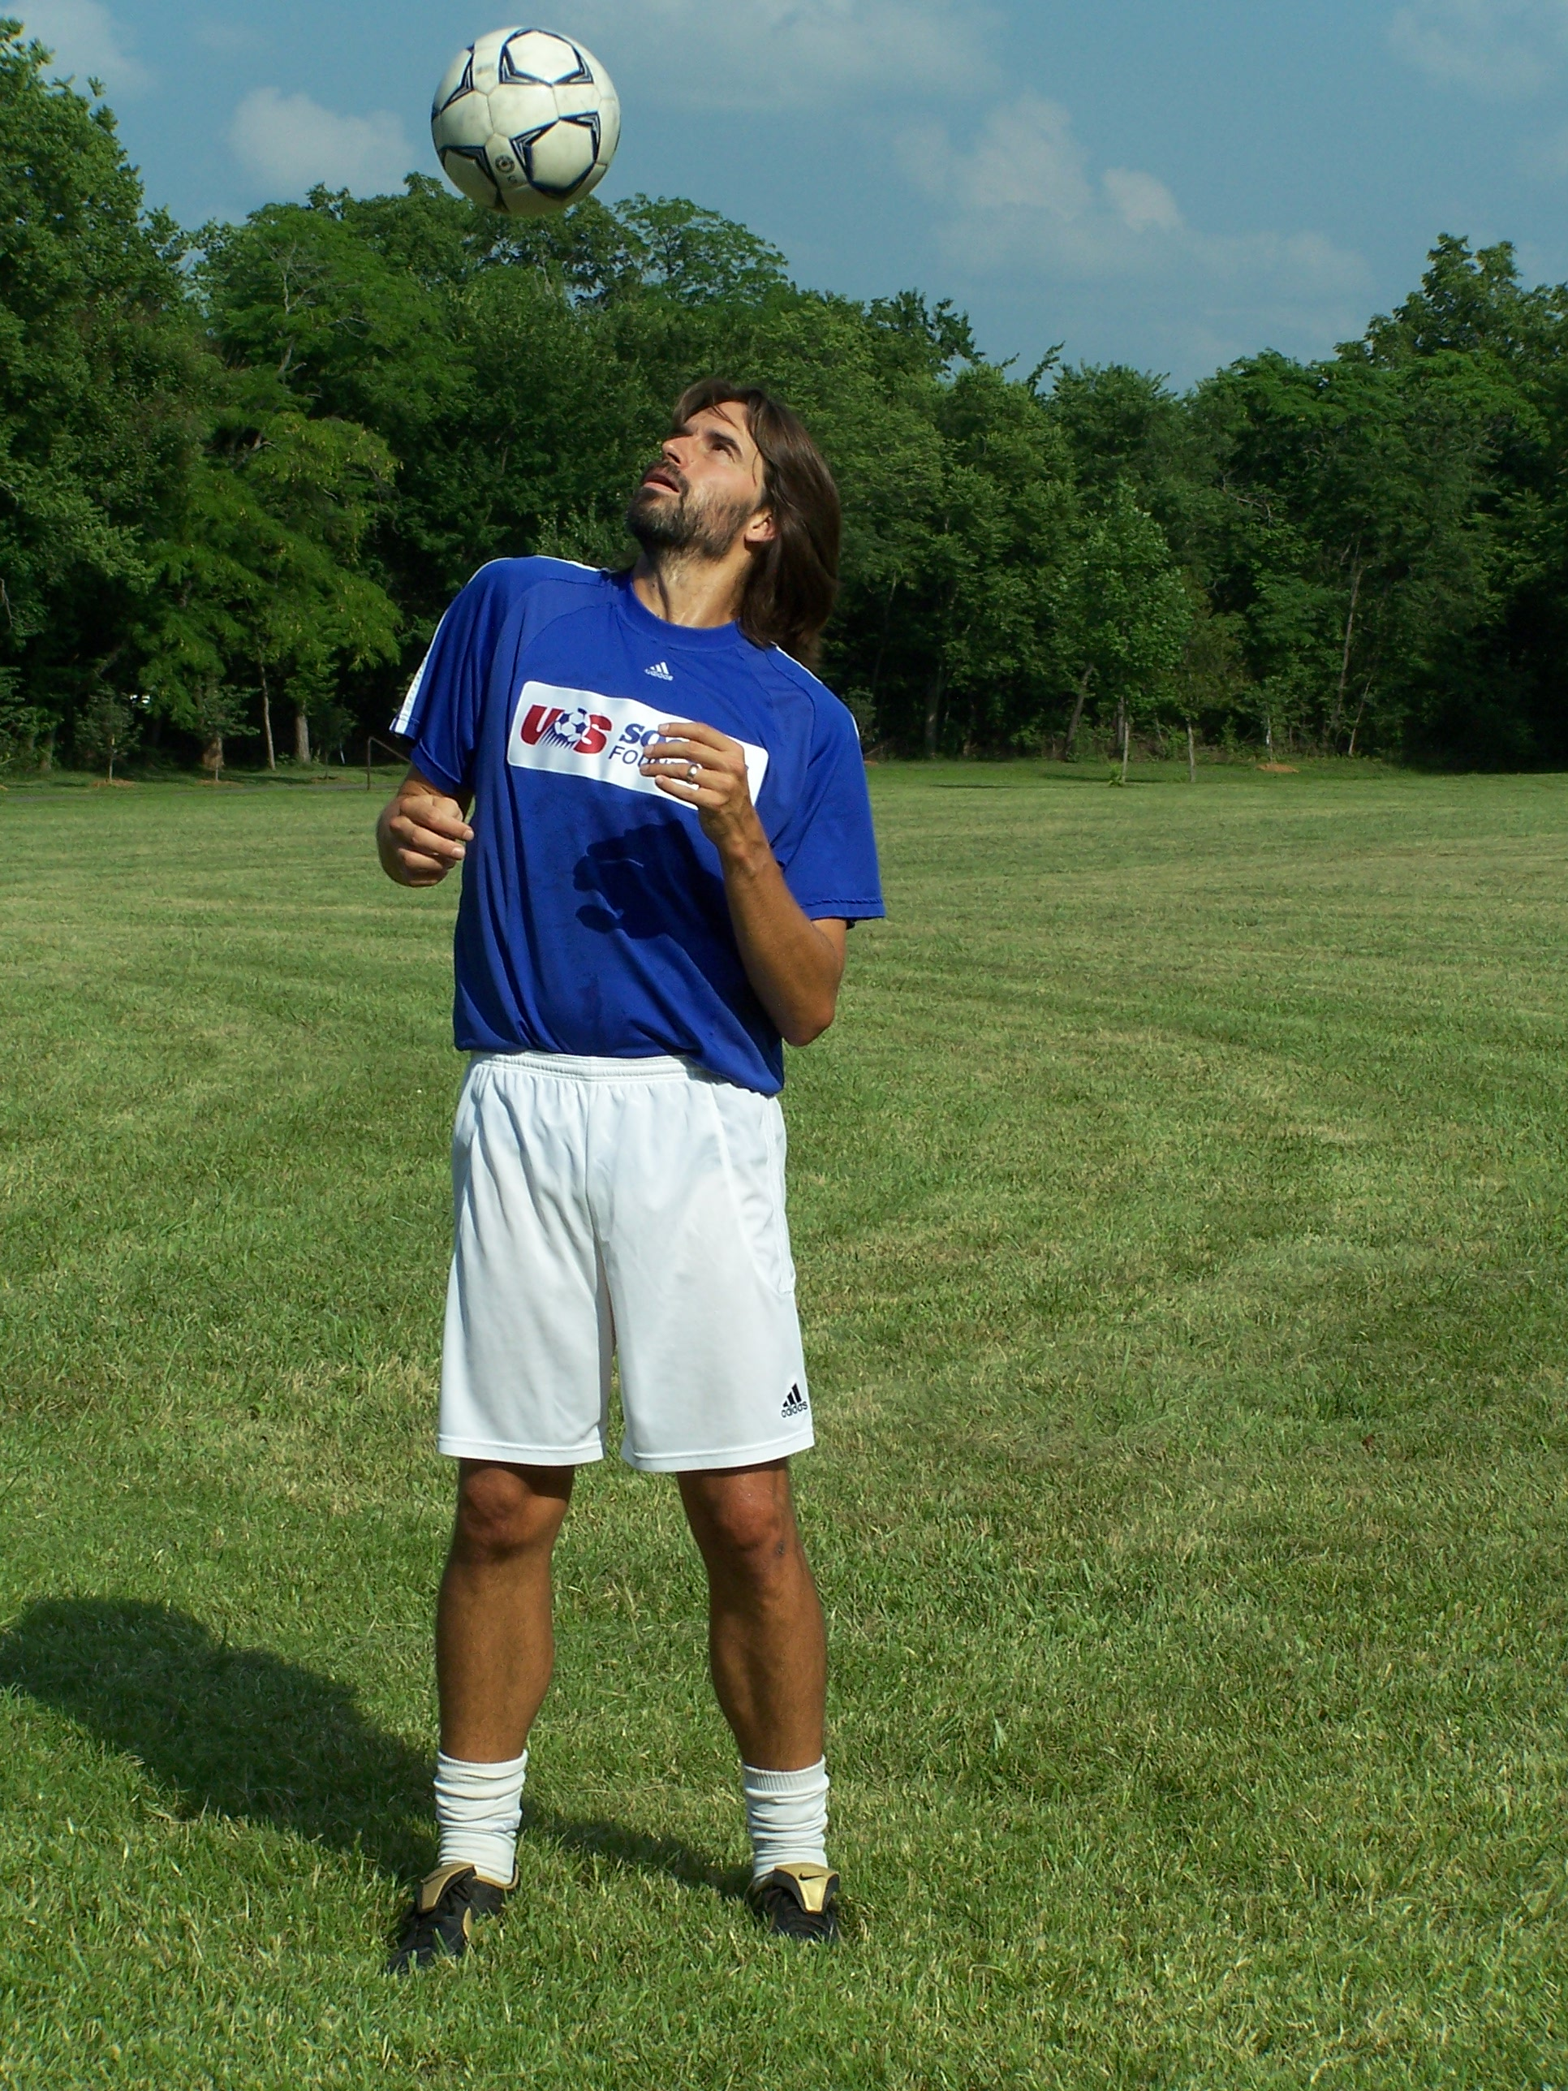

Head Juggle

Shoulder Juggle

“I think football would become an even better game if someone could invent a ball that kicks back”.
Eric Morecambe

LEVEL 1

 | From Hands | Off Bounce | From Ground
- Right lace, Right Lace
- Left lace, Left Lace
- Right inside, Right Inside
- Left inside, Left inside
- Right outside, Right outside
- Left outside, Left outside
- Right heel, Right heel
- Left heel, Left heel
- Right thigh, Right thigh
- Left thigh, Left thigh
- Chest, Chest
- Right shoulder, Right Shoulder
- Left shoulder, Left Shoulder
- Head, Head
- Find a surface we haven’t used! (I can think of 5 more at least! Can you think of any?)
- Set a juggling record for yourself. Use your hands to start it if you have to, or better yet off the bounce. But remember, you can’t do that forever.

These are the primary surfaces we will be using for all sequences. (Did you know we would have 14?)

Remember you need to be practicing lifting the ball into the air to start juggling (see LIFTS section). You will have to do it for Level 3!!

"What Zidane can do with a football, Maradona could do with an orange." Michel Platini

LEVEL 2

In the 1998 World Cup in the USA, Dennis Bergkamp was playing for Holland against Argentina. This was a great game with 2 of the best teams in the world and it would be decided on a juggle.

The left defender for Holland had the ball 10 yards into his own half, when he saw Bergkamp breaking down the far right side of the field.
He immediately hit a 60+ yard ball in the air towards the corner of the box for Bergkamp to run onto.

Bergkamp and his defender were sprinting side by side as the ball came over his shoulder. He took one juggle with the laces of his right foot, taking all the spin and speed out of the ball. His next touch nutmegged Argentine defender, Roberto Ayala. While Roberto watched helplessly, Bergkamp then volleyed the ball into the back of the net with his third, touch winning the game.

An unbelievable goal made possible because of Bergkamp’s ability to control a ball from any direction at any speed. This is what juggling can do for you!

For this level, have the ball bounce off the ground and then juggle with the correct surface. Ball may be dropped from hands to ground to start. If you can start it from the ground, all the better!!
"We dominated for 99% of the game; it was the other 3% that cost us." Ruud Gullit
LEVEL 2

 | Off the Bounce | From the Ground
- Right Lace, Left Lace
- Left Lace, Right Lace
- Right lace, right outside
- Left lace, Left outside
- Right lace, right inside
- Left lace, left inside
- Right lace, right heel
- Left lace, left heel
- Right lace, right thigh
- Left lace, left thigh
- Right lace, chest
- Left lace, chest
- Right lace, right shoulder
- Left lace, left shoulder
- Right lace, head
- Left lace, head
- Right lace, left lace, right lace
- Left lace, right lace, left lace
- Right lace, left thigh, right thigh
- Left lace, right thigh, left thigh
- Make your own sequence using 3 surfaces in a different combination than we have done.
- Beat your previous juggling record. If you still cannot start it from the ground, drop it and start off the bounce

P.S. I hope you’ve been practicing your LIFTS (see LIFTS section)!!

Congrats on finishing level 2!

“All good athletes make mistakes; the great ones learn to make that mistake only once." Raul Lopez

LEVEL 3

George Best was one of the best players to ever lace on cleats. He played for Manchester United for most of his career, amazing fans and defenders alike with his touch and skill. Pele called him the greatest player he had ever seen!

Some things he did just seemed to be done to amuse himself.

He once had the ball in the corner with a defender right on his back. Instead of just shielding it and waiting for the defender to kick it out of bounds, he hit the ball off the corner flag, through the defender’s legs and spun around him to get a cross of!

An artist just has more tools to solve a problem, and George Best had a belt full.

I’m trying to give you as many tools as I can. The more tools you have, the more creative you can be because you will have more options.

Hopefully you have been practicing your lifts (see LIFT section) so you have at least one lift that you can use to get the ball into the air to start juggling. All standing combos from here on out start with the feet from the ground. You may use any lift you want, unless stated otherwise.

We add the Foot Stall to this level. A stall is where the ball is balanced on a surface. If you can stall a ball on a surface, then you can trap a ball with that surface. You demonstrate complete control of how fast the ball is traveling and the touch it takes to stop it completely out of the air.

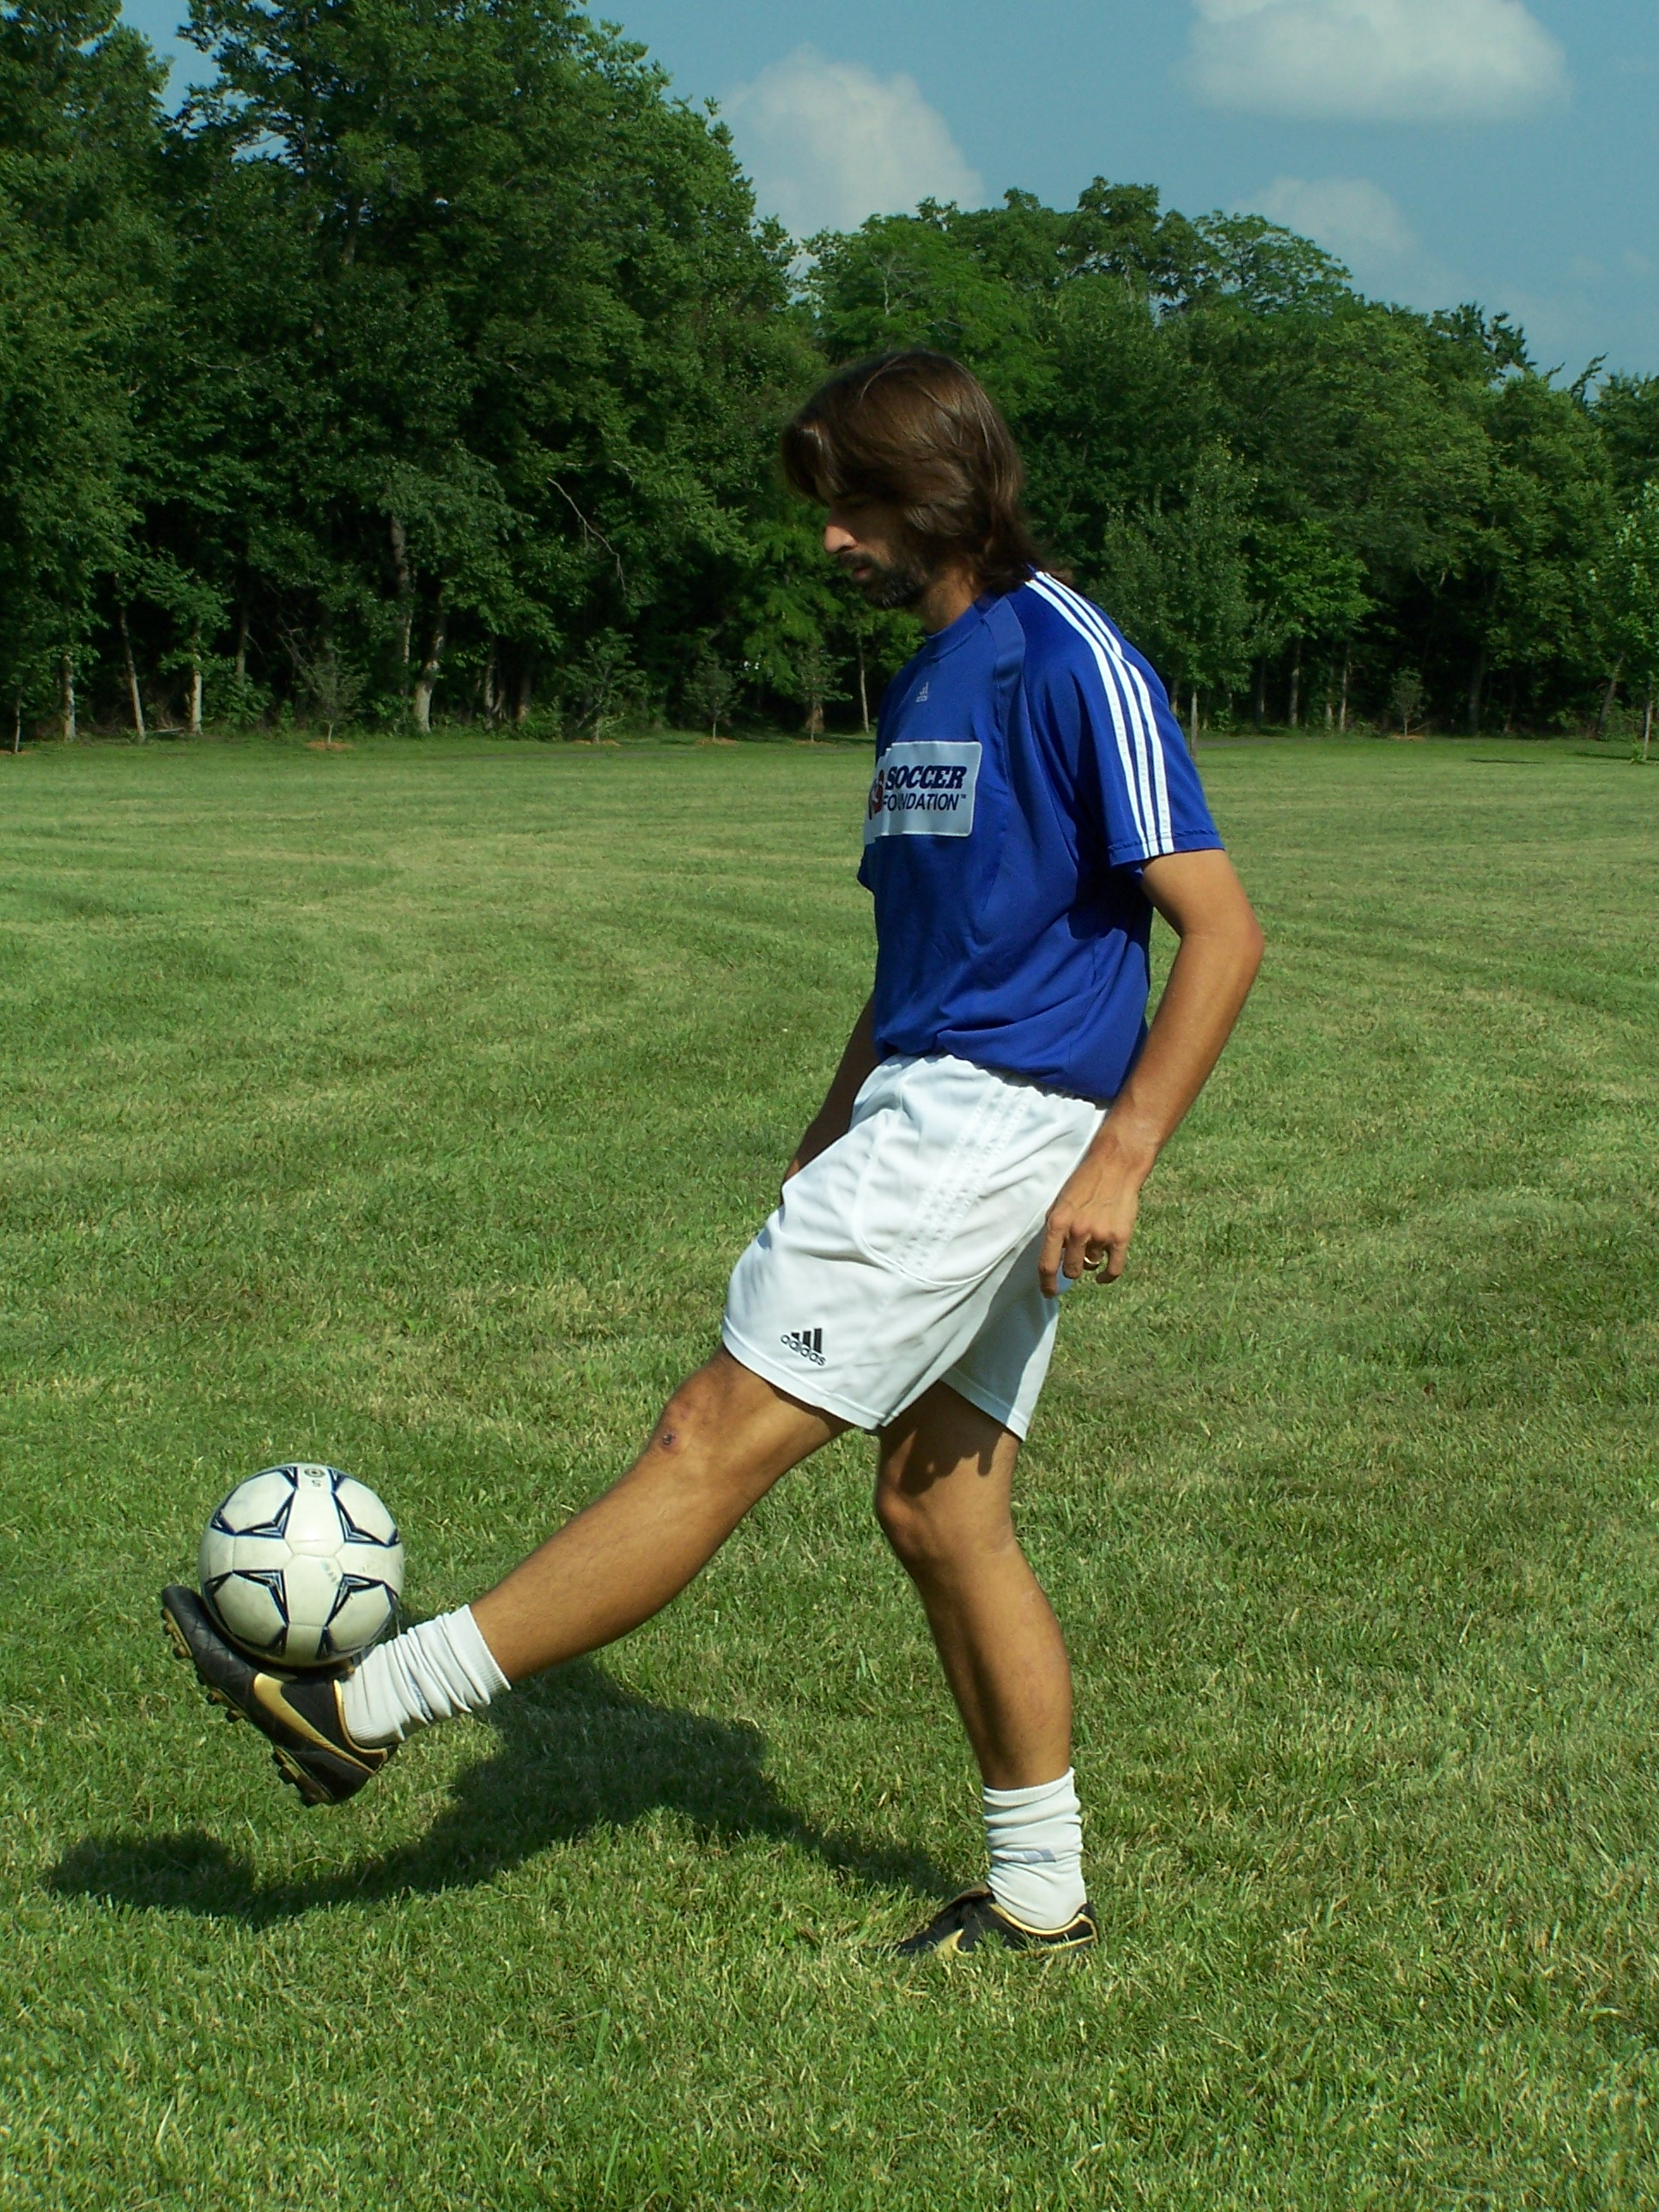

Foot Stall world Record: Abraham Munoz (USA), 13:36 min, on 3 August 2001 in Carpentersville

NOTE: Sometimes you may need to take a couple touches to get a rhythm. It does not matter how many touches you take prior to a combo, just that the combination is done in order.
LEVEL 3

From the Ground
- Right lace, head, left lace
- Left lace, head, right lace
- Right lace, right thigh, right lace
- Left lace, left thigh, left lace
- Right lace, right outside, right lace
- Left lace, left outside, left lace
- Right lace, right inside, right lace
- Left lace, left inside, Left lace
- Right lace, right heel, right lace
- Left lace, left heel, left lace
- Right lace, right thigh, head, right lace
- Left lace, left thigh, head, left lace
- Right lace, left thigh, right thigh, left lace
- Left lace, right thigh, left thigh, right lace
- Right lace, right outside, left outside, left lace
- Left lace, left outside, right outside, right lace
- Right lace, right inside, left inside, left lace
- Left lace, left inside, right inside, right lace
- Right lace, right heel, left lace, left heel
- Left lace, left heel, right lace, right heel
- Right lace, right thigh, chest, left thigh, left lace
- Left lace, left thigh, chest, right thigh, right lace
- Stall the ball on your right foot for 3 counts
(1 Mississippi, 2…etc.)
- Stall the ball on your left foot for 3 counts
- Make up a 5 surface combination we haven’t done.
- Set a new juggling record. No hands remember!

"He will be called Ronald, because we like going to McDonald's."
on his baby - Ronaldo

LEVEL 4

On the Ground

In Level 4 we switch it up a bit. One of the best ways to practice touch and control in juggling is by sitting on the ground and juggling.

Sit, leaning back slightly, with your legs out, and then prop yourself up with your hands.

Bend your knees and lock your ankle with toes pointing straight out when you juggle.

Juggling on the ground is about controlled touches. You want to strike the ball just hard enough to keep it bouncing. You may use your hands at first to get the feel for it. But eventually you can start it without them. Start it with your hands, but see if you can do each combo starting from the ground as well!

There is a guy in Holland called the Juggle King. He sits in the square all day and juggles mostly on the ground. His touch is so impressive people give him money for performing!

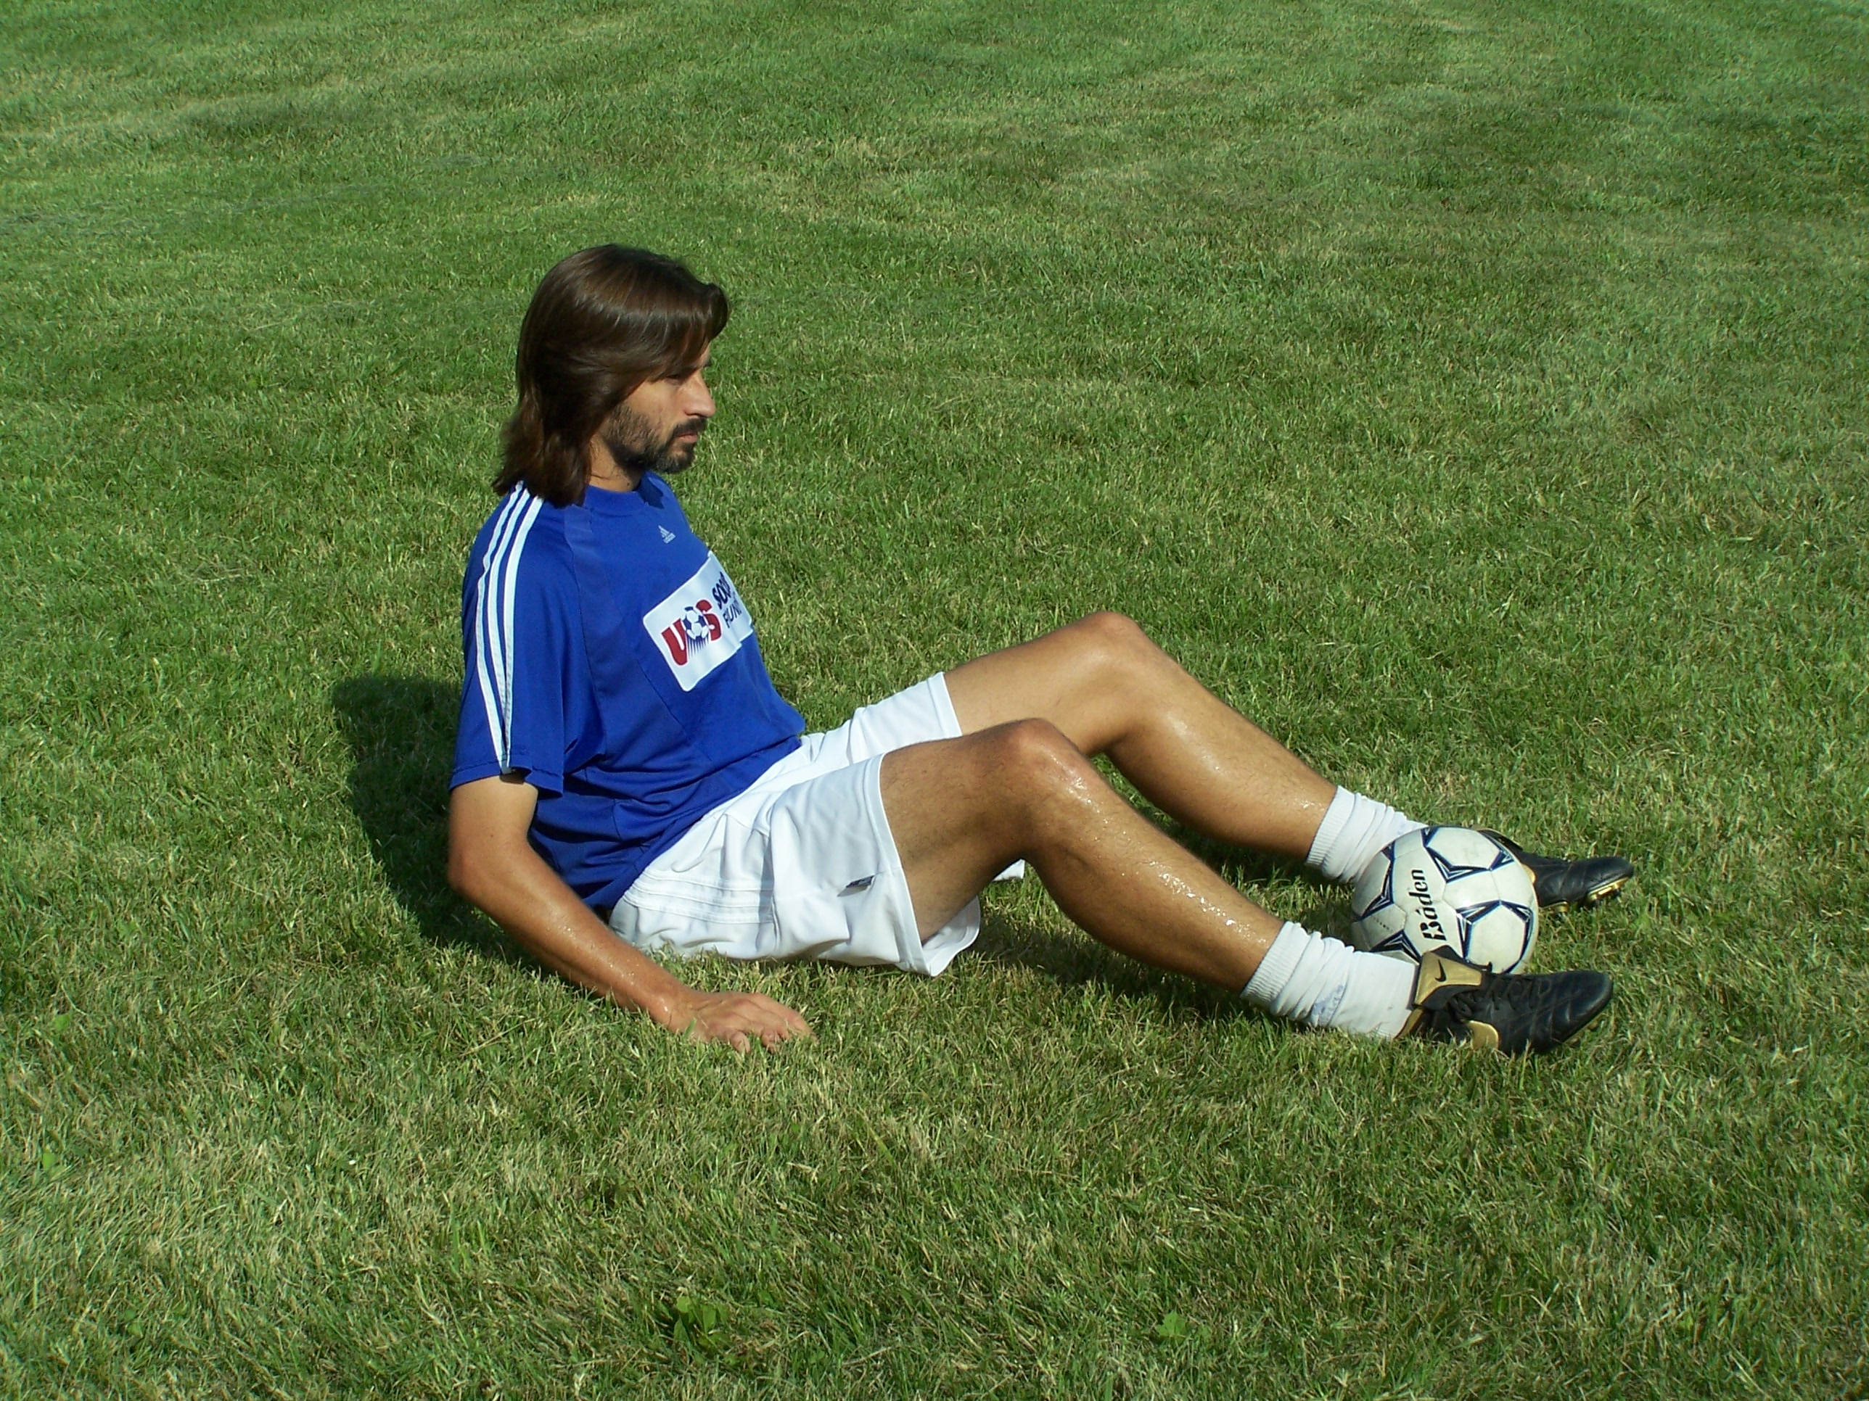

Ground position

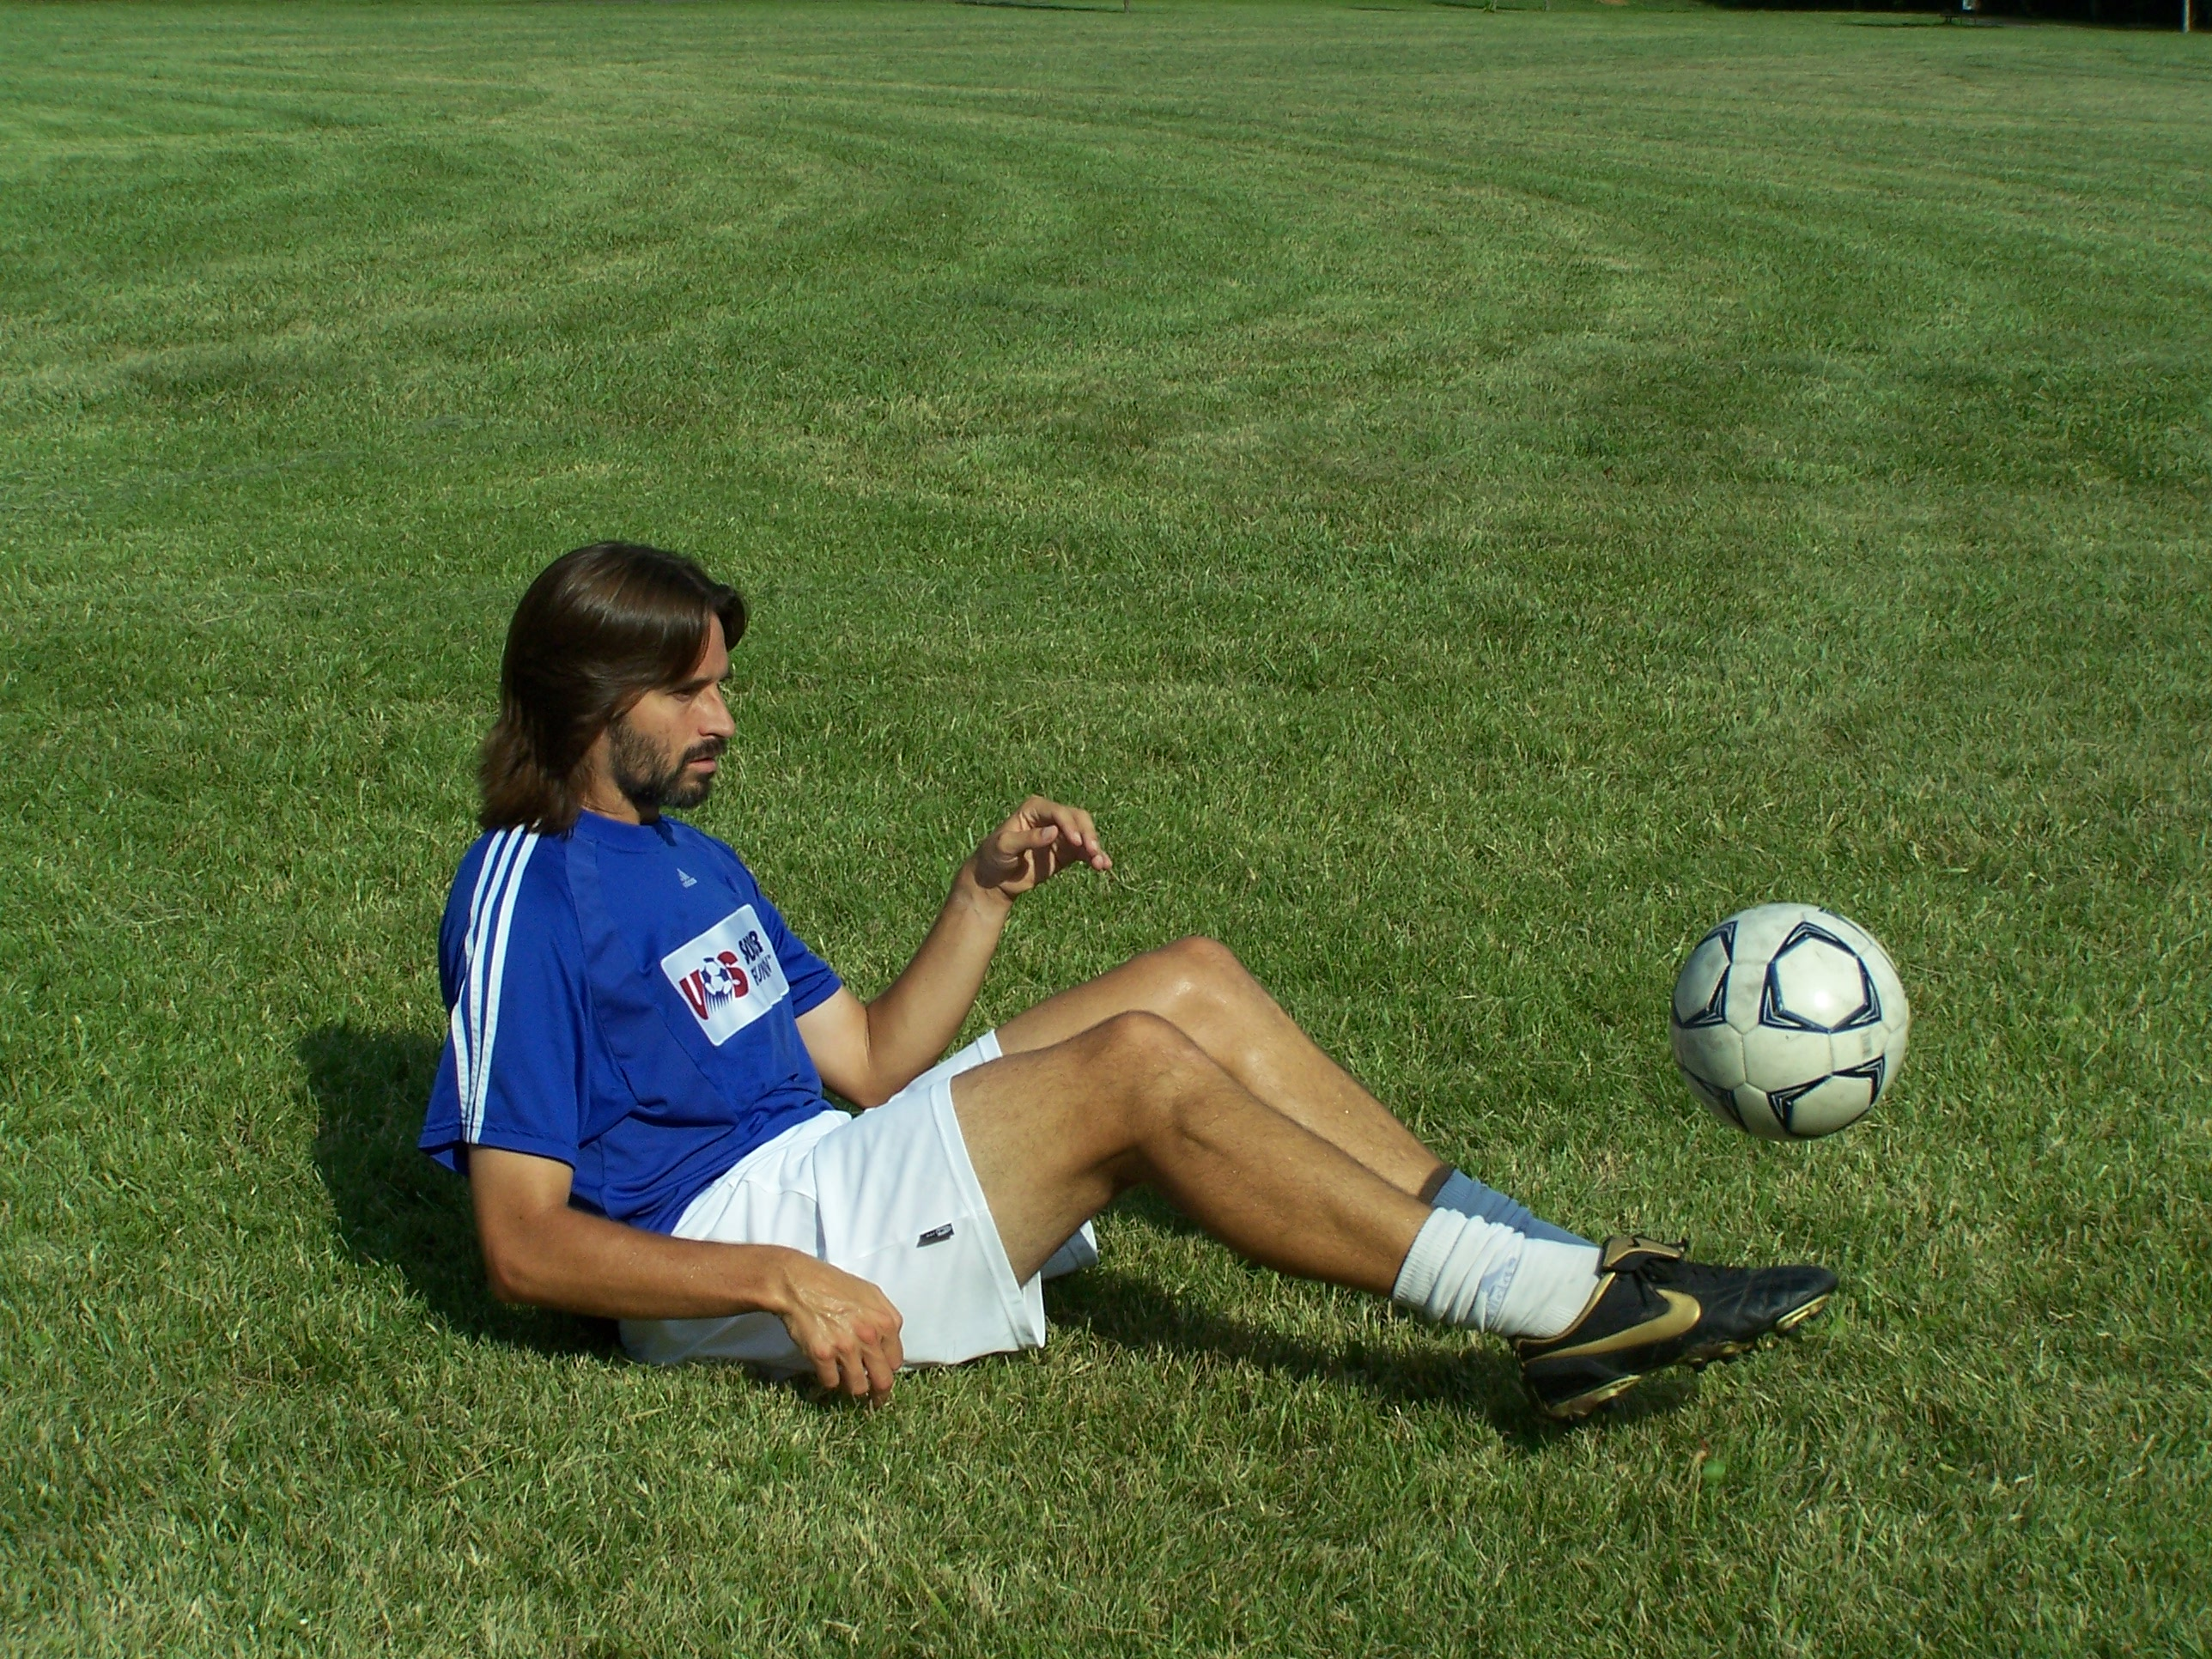

Ground Juggle

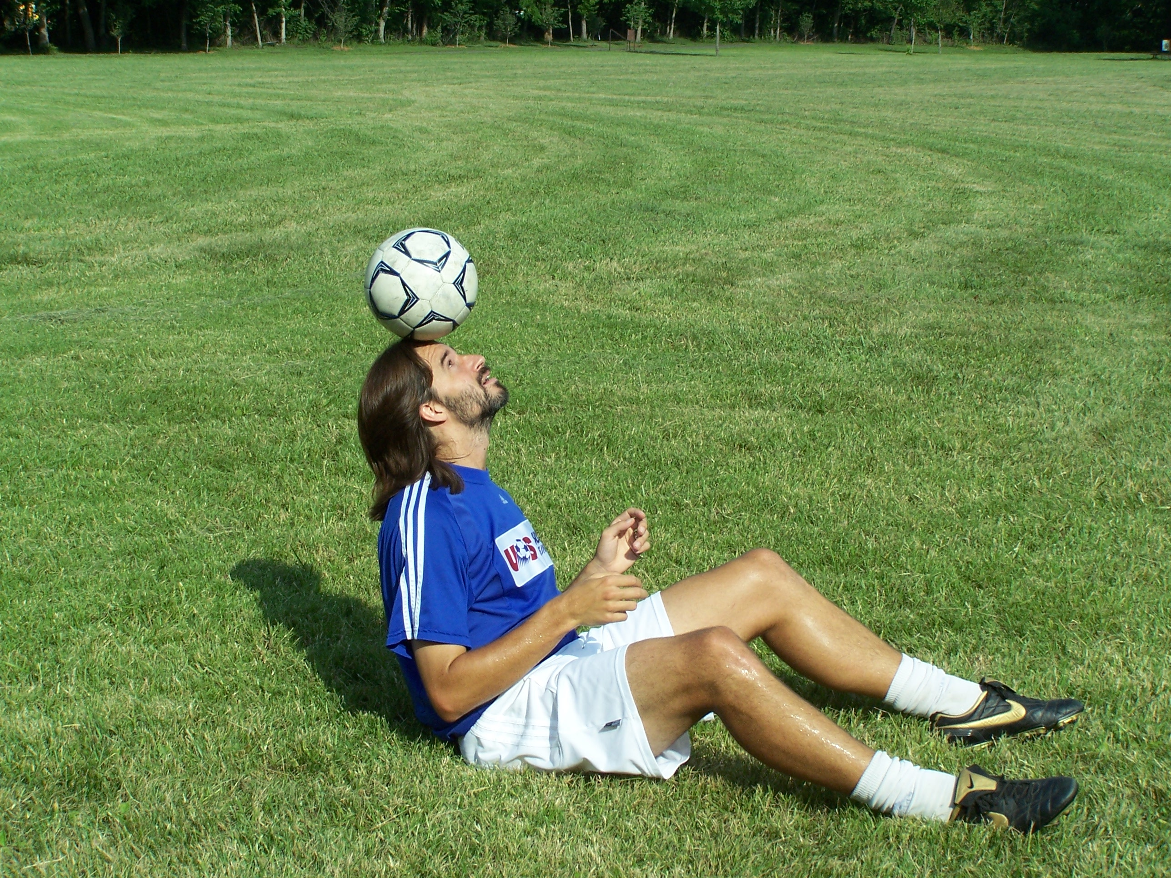

Sitting Head Stall

LEVEL 4

 | From Hands | From ground
- Right Lace catch
- Left lace, catch
- Right lace, Left lace
- Left lace, right lace
- Right lace, right lace
- Left lace, left lace
- Right lace, left lace, right lace, catch
- Left lace, right lace, left lace, catch
- Right lace, head, catch
- Left lace, head, catch
- Right lace x 3
- Left lace x 3
- Right Lace, Left Lace, Right Lace, Left Lace
- Left lace, right lace, left lace, right lace
- Head stall, (Knees bent, half sit-up, ball resting on hairline) See how long you can keep it there | 20 attempts | You may place the ball on your head.
- Set a sitting juggling record
- Try juggling on the ground with 4 or more surfaces.
- Stand up and set a new personal juggling record starting the ball from the ground.

"Sometimes in football you have to score goals."
Thierry Henry

LEVEL 5

Intermediate

In level 5 we start crossing the body from right to left even more, as well as changing the height of the ball a lot more.

From the Ground
- Right lace, left lace, left thigh, right thigh, head, right lace
- Left lace, right lace, right thigh, left thigh, head, left lace
- Right lace, head, right outside, right lace
- Left lace, head, left outside, left lace
- Right lace, right inside, left inside, left lace, head
- Left lace, left inside, right inside, right lace, head
- Right lace, right heel, head, chest, left lace
- Left lace, left heel, head, chest, right lace
- Right lace, right shoulder, left thigh, left lace, left shoulder
- Left lace, left shoulder, right thigh, right lace, right shoulder
- Right Foot stall 5+ counts
- Left Foot stall 5+ counts
- Right Lace, chest, left thigh, right thigh, left lace, Head
- Left Lace, chest, right thigh, left thigh, right lace, Head
    - Set an outside of the foot record.
    - Set an inside of the foot record
- Set a heading record
- Set a new personal juggling record

"Why is there only one ball for 22 players? If you gave a ball to each of them, they'd stop fighting for it"
Unknown
LEVEL 6

With a Twist

Congratulations on getting this far! We have been pretty straightforward with the juggling so far. No twisting, turning, jumping, climbing, or falling has been added to the combinations. Well, now we are going to stretch your agility and coordination. You’re going to need 2 chairs, an 8-foot-long 2x4, and a lemur. Kidding.

We are, however, going to start changing the body position, using sitting, squatting, and turning 180 (half a circle) and 360 degrees (whole circle).

One of the best players in the world at using juggling as a tool in a game is Ronaldinho.

One of his favorite moves is to receive a ball out of the air with his chest while shielding it from a defender. Then, before the ball hits the ground, he juggles the ball with his heel or his laces over the defender’s head and spins behind him.

That is one thing that you are going to be learning in this section.
"First I went left, he did too. Then I went right, and he did too. Then I went left again, and he went to buy a hot dog."
On his move on Stephane Henchoz of Liverpool - Zlatan Ibrahimovic
LEVEL 6

From Ground
- Right lace, over the head, turn 180, left lace
- Left Lace, over the head, turn 180, right lace
- Right lace, high in the air, turn 360, right lace
- Left lace, high in the air, turn 360, left lace
- Right lace, left lace, right outside, over the head, turn 180, left lace
- Left lace, right lace, left outside, over the head, turn 180, right lace
- Right lace, left lace, right lace, left lace, head, turn 180, chest, right lace.
- Left lace, right lace, left lace, right lace, head, turn 180, chest, left lace.
- Right lace, right heel, over the head, turn 180, left lace, left lace
- Left lace, left heel, over the head, turn 180, right lace, right lace
- Right lace, sit on ground, right lace, right lace
- Left lace, sit on ground, left lace, left lace
- Right foot stall 3 seconds, toss to left foot, left foot stall 3 seconds
- Left foot stall 3 seconds, toss to right foot, right foot stall 3 seconds
- Right lace, squat or lunge and hit off right knee, stand, right lace
- Left lace, squat or lunge and hit off left knee, stand, left lace
- Right lace, Head 5x, Left Lace
- Set a new personal juggling record.

"An inch or two either side of the post and that would have been a goal." Dave Bassett

LEVEL 7

WOW! You have really come a long way!! Finishing the first 6 levels of this program is a great accomplishment!! You have probably seen a big improvement in your control out of the air with the ball. Your confidence receiving balls has probably improved tremendously and soccer is even MORE FUN!! I don’t doubt that you have done some things in practice or games that surprised even you!! YOU’RE BECOMING AN ARTIST!!

So, now that you think you have arrived…time to step it up a notch. You are no longer a beginner and your touch has improved to the point where you need to be stretched, both physically and creatively. You may find some easier than others, and the others will be hard to get through. If you do get stuck on one and start to get really frustrated, go on to the next one and then come back and do it later. Reminder: you need to finish all of them in the level before going on to Level 8. Have fun!! Don’t give up!!

I saw Ronaldinho receive a ball on his chest with 2 defenders within arm’s reach of him. Instead of letting the ball drop to the ground, he stalled it on his chest, keeping it there as he ran between the 2 defenders into open space before letting it drop to the ground safely. You are about to learn that.

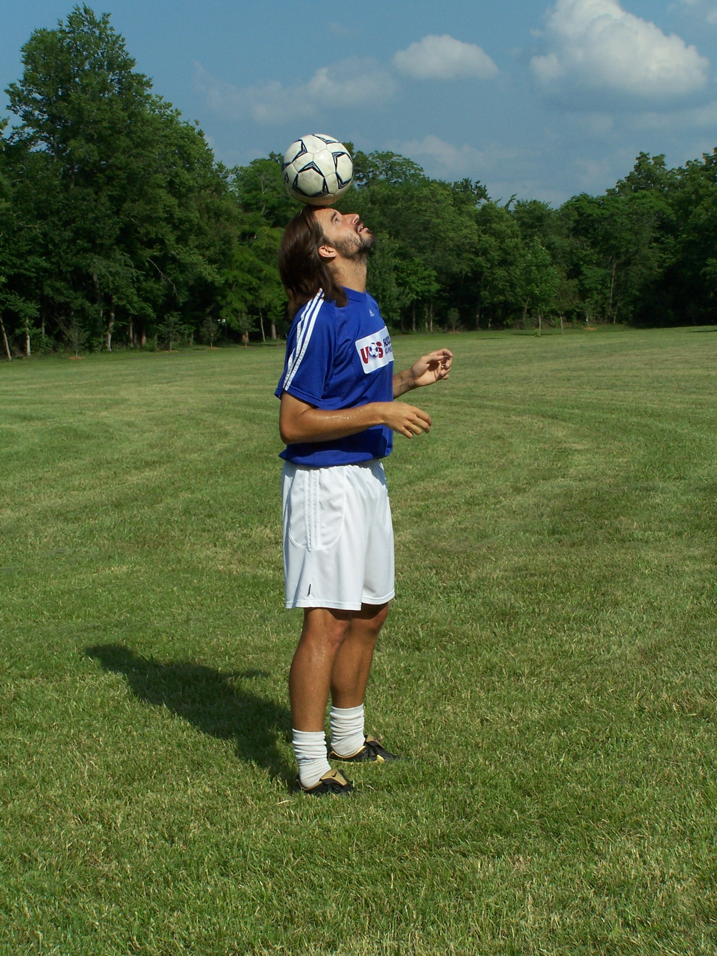

*Keys to Head Stall: Head back, put ball on hairline, keep eyes on ball.

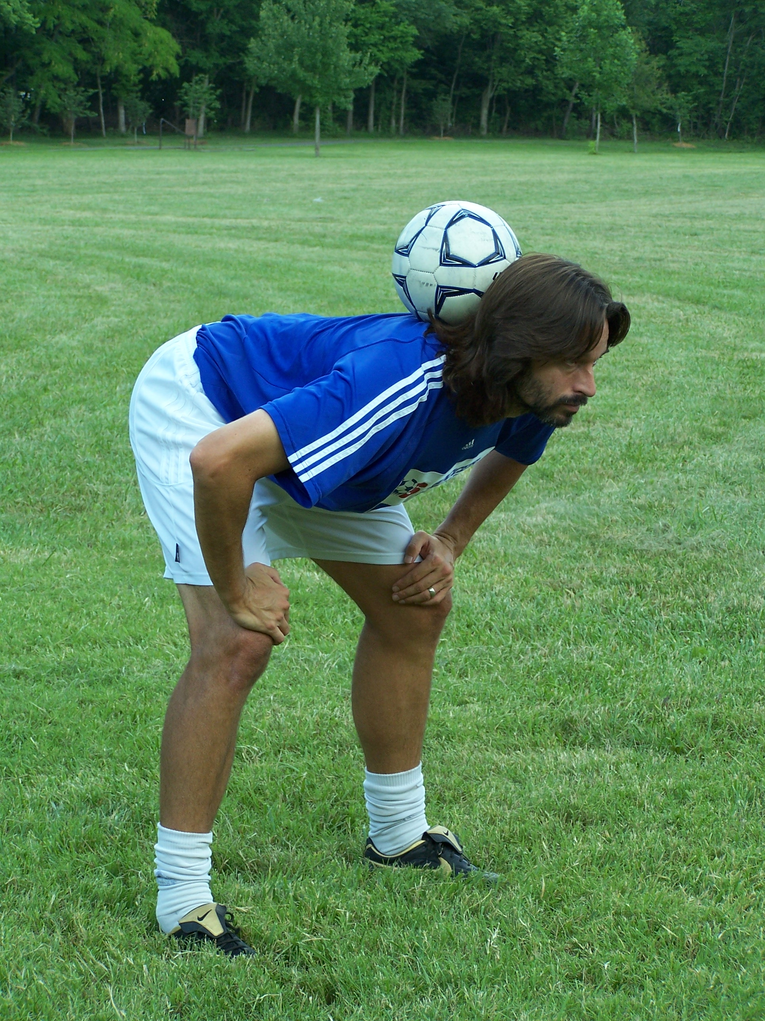

** Keys to the Neck Stall: Keep CHIN UP, keep shoulders back, and bend at the waist. The ball actually doesn’t touch your neck, but rests on your shoulders and the back of your head.

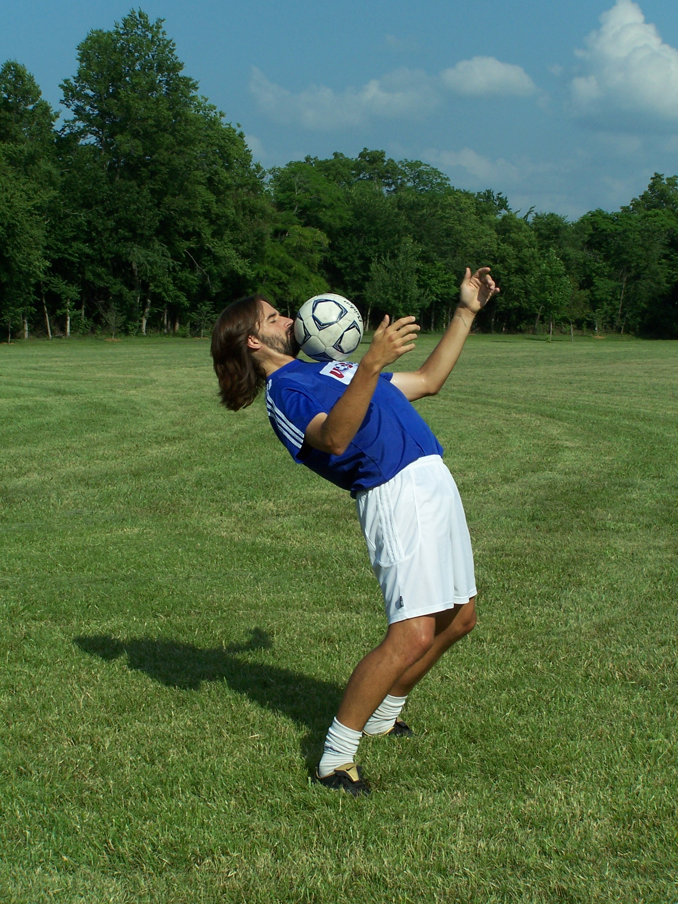

*** Keys to Chest Stall: Bend knees first, then bend backwards from the waist. Keep your chin up so you can see the ball and set the ball right below your face on your chest.

LEVEL 7

From Ground
- Right lace, left lace, right lace 2x, left lace 2x, right lace 3x, left lace 3x
- Left lace 3x, right lace 3x, left lace 2x, right lace 2x, left lace, right lace
- Right lace, left lace, right lace 2x, left lace 2x, right lace 3x, left lace 3x,
Right lace 2x, left lace 2x, right lace, left lace
- Left lace, head, right shoulder, head, left shoulder, right lace
- Right lace, right inside, right outside, left lace, left inside, left outside
- Left lace, left inside, left outside, right lace, right inside, right outside
- Right lace, right heel, left heel, right lace
- Left lace, left heel, right heel, left lace
- From hands, head stall 5+ seconds*
- Laces, sit on the ground, keep juggling and stand back up, and juggle 3x
- From Hands, Set the ball on the back of your neck and stall it 10+ seconds. **
- From Hands, Neck Stall, do a push up with ball on your neck
- Right lace, left lace, right lace, trap ball between your knees.
- From Hands, set ball on chest and stall for 5+ seconds. ***
- Left Lace, Head 10x, right lace
- Right Lace, right thigh, right shoulder, head, left shoulder, left thigh, left lace. (also called Around the World)
- Set a new personal juggling record

"You lads line up alphabetically by height."

Archie Knox - Ex. Rangers Assistant Manager

LEVEL 8

Stalls and traps

As we learned before, a stall is where the ball is balanced on a body part. A trap (in juggling) is where the ball is caught between two surfaces. These must be achieved from juggling. Stalls must be held for 3 seconds. When putting together combinations, the ball may not touch the ground at any time. It is ok to use as many juggles as is needed to transfer between each.

- Laces stall
- Outside of the foot stall
- Between knees trap
- Between ankles trap
- Between Calf and hamstring (back of the top of the leg and back of the bottom of the same leg.) also known as Chicken Wing.
- Chest stall
- Head stall
- Neck stall
- Back stall
- Lap stall
- Lips stall – also called Kiss stall
- Thigh-Chest trap
- Standing on one foot, other foot traps ball against standing leg. Also called the Flamingo

Outside of the foot stall

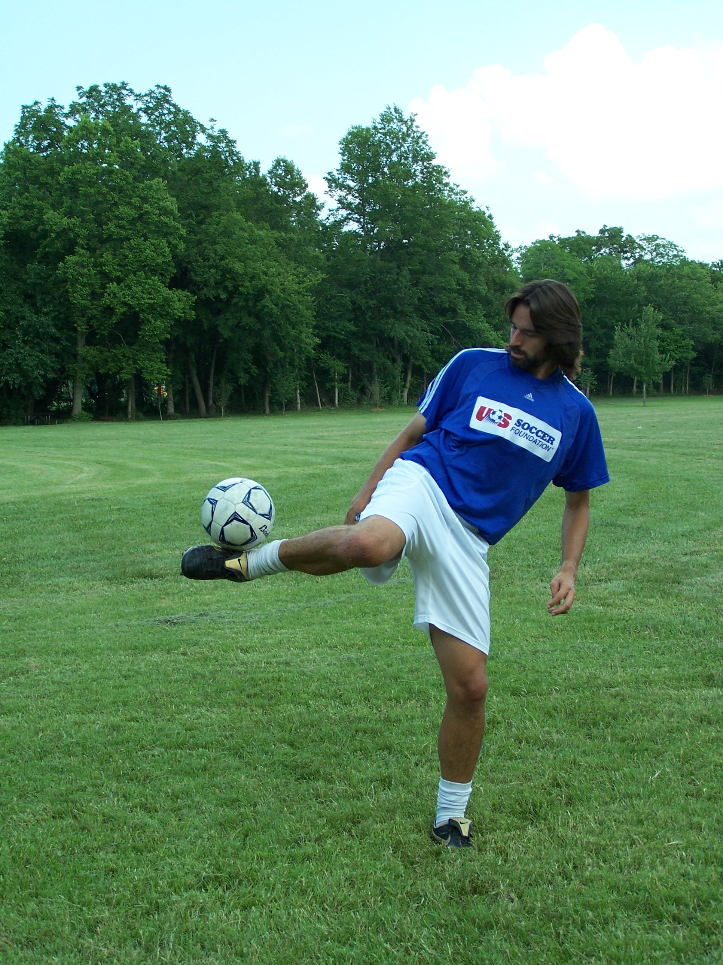

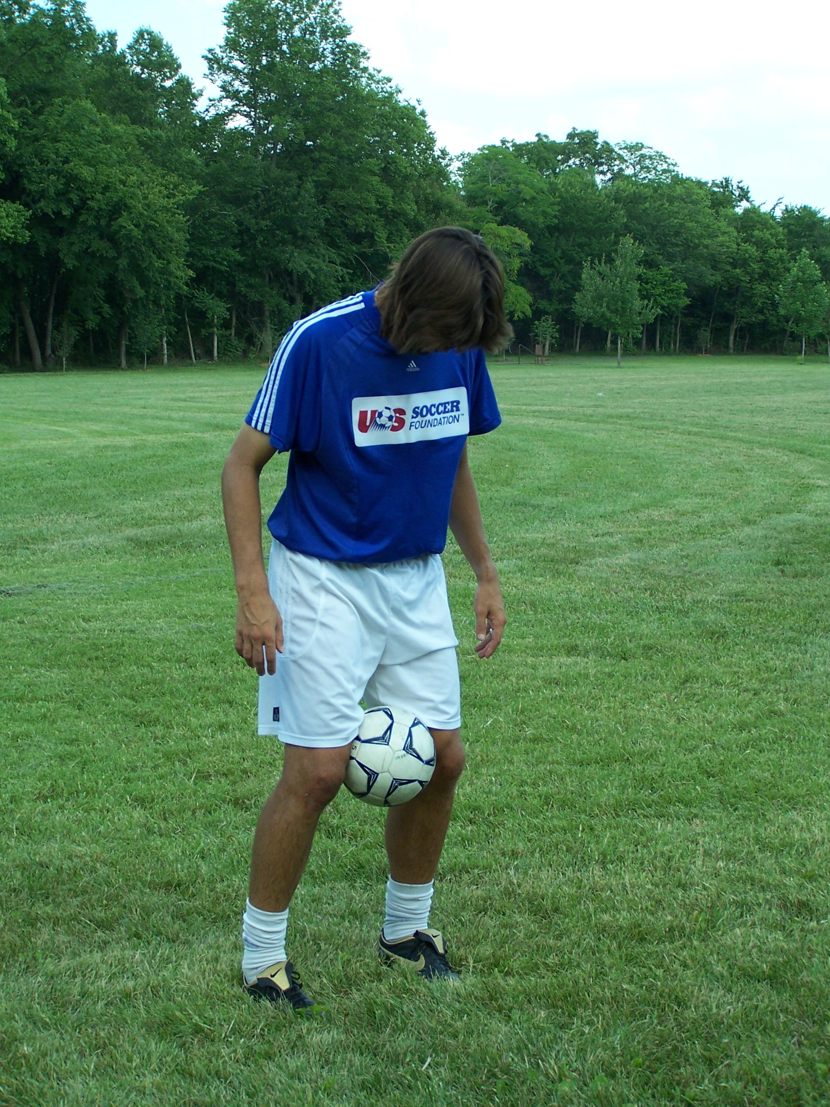

Knee Trap

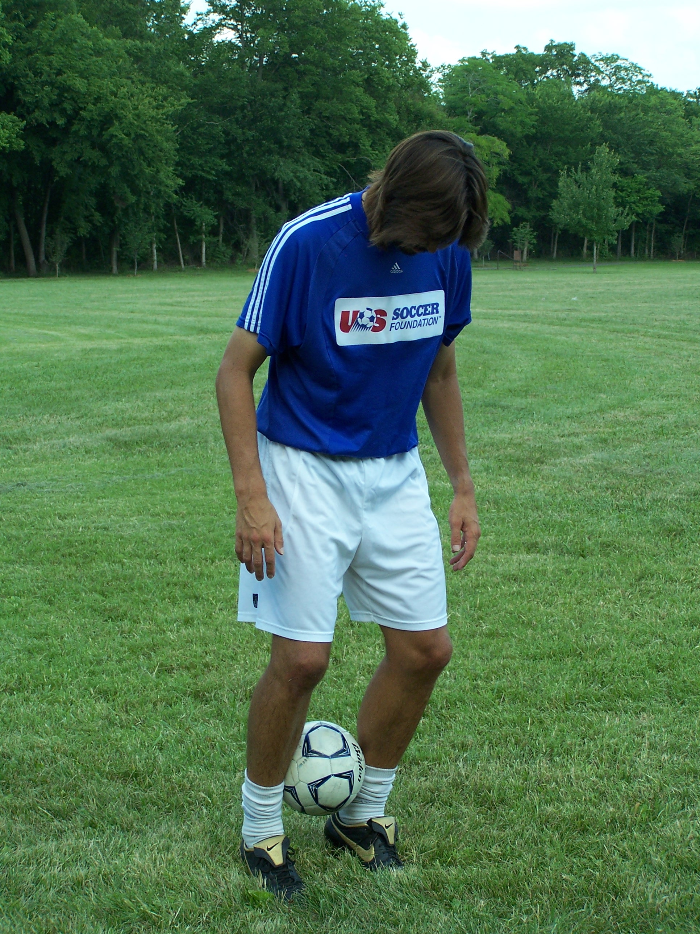

Ankle Trap

Back Stall
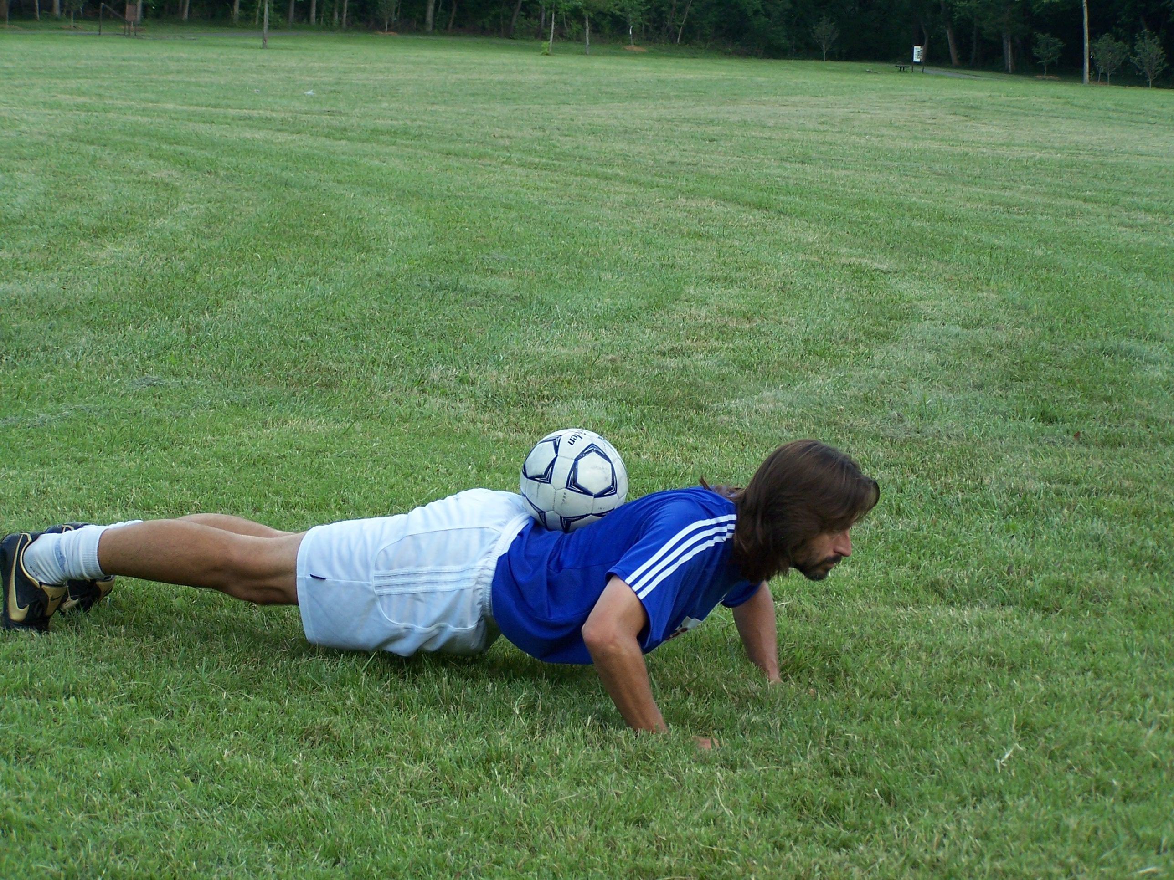

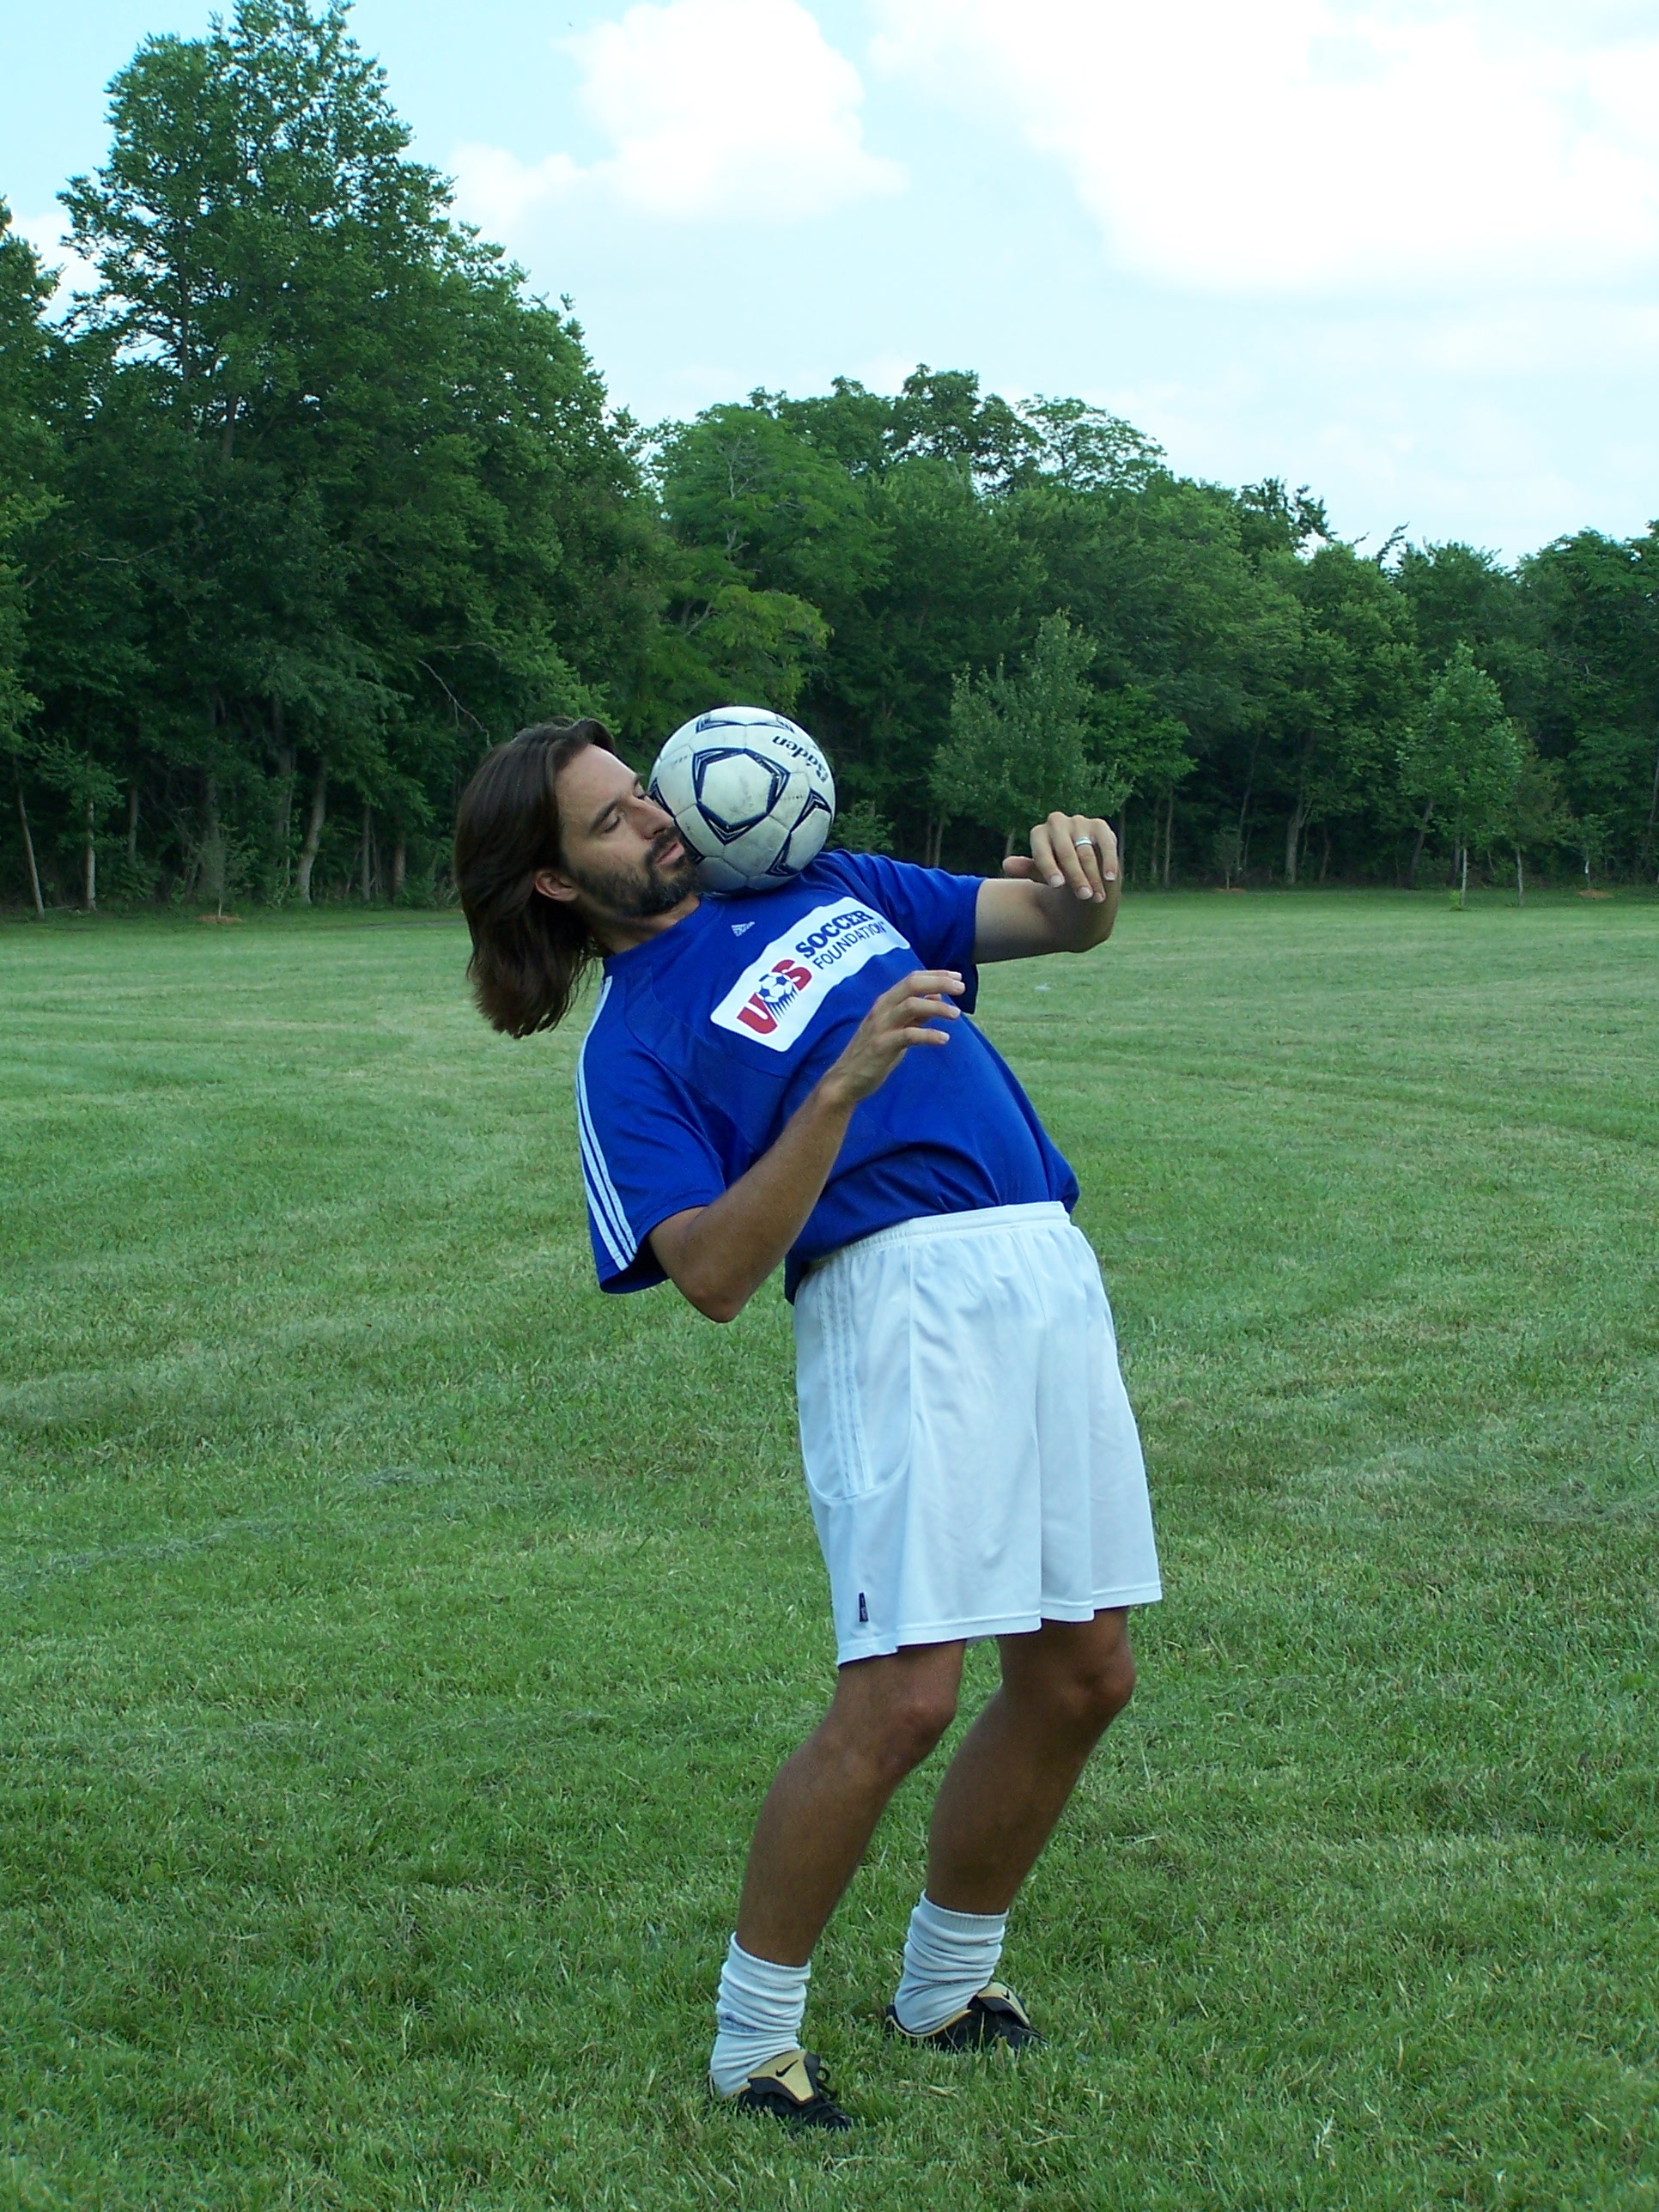

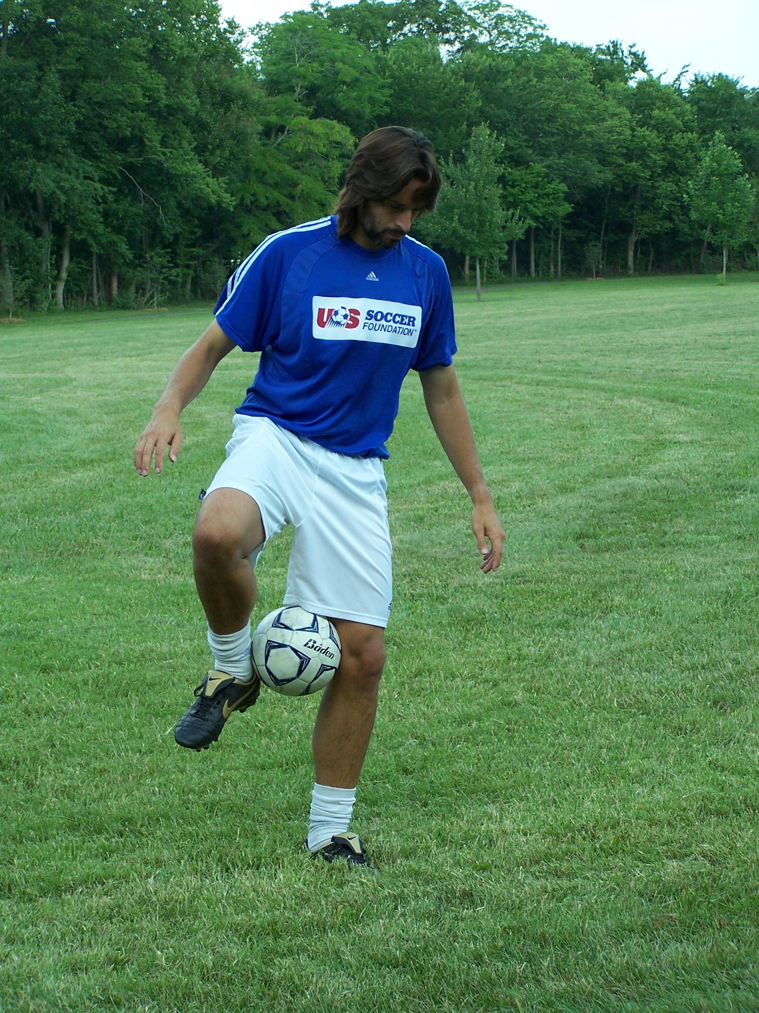

Flamingo

Shoulder Stall

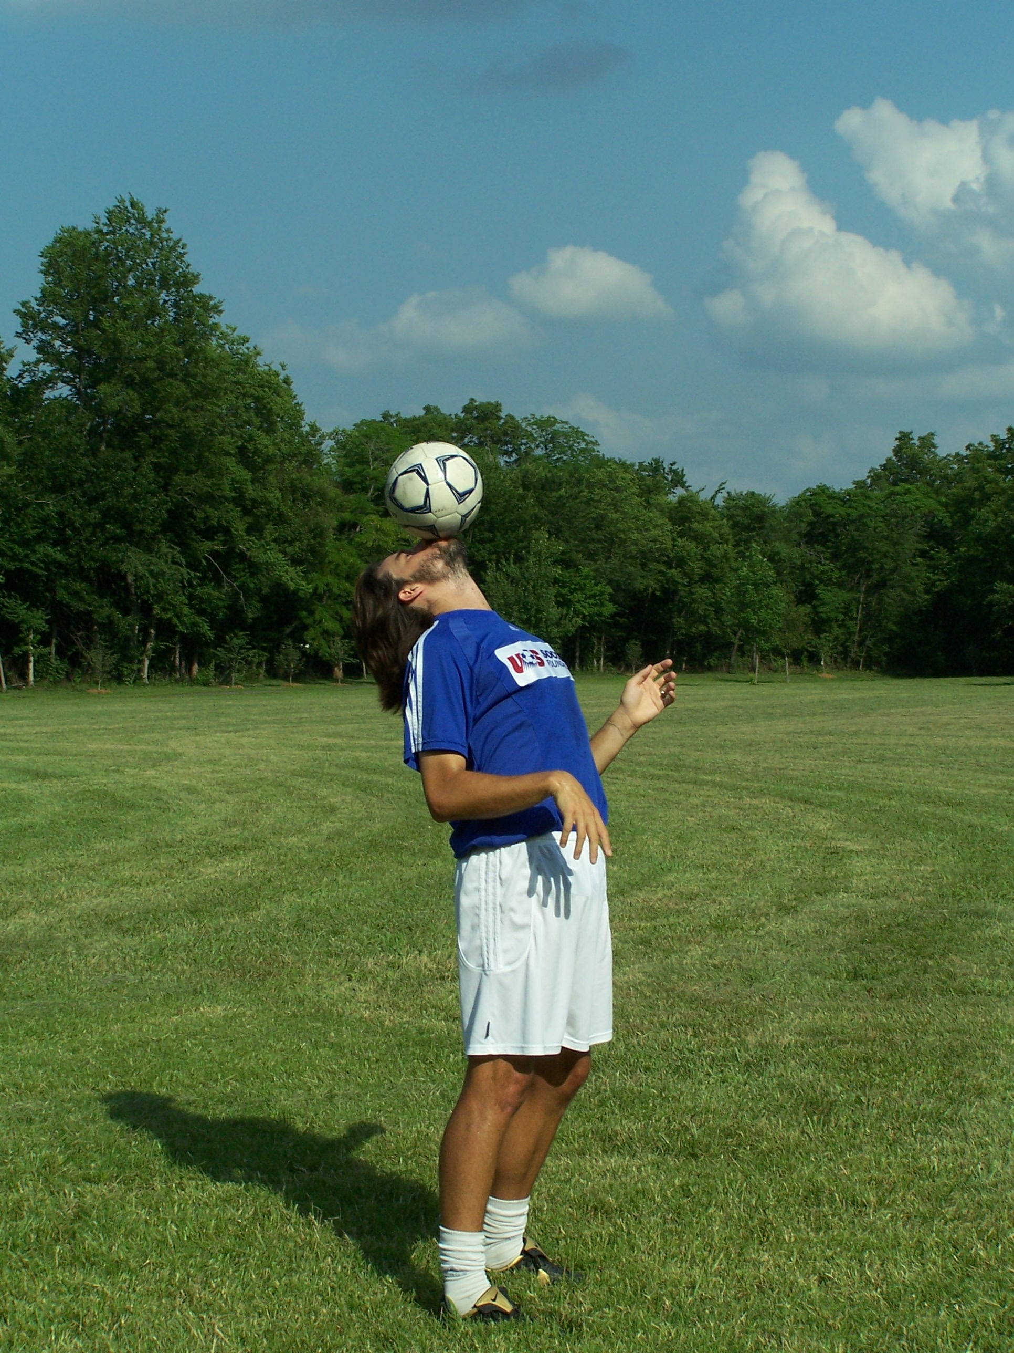

Kiss Stall

Lap Stall

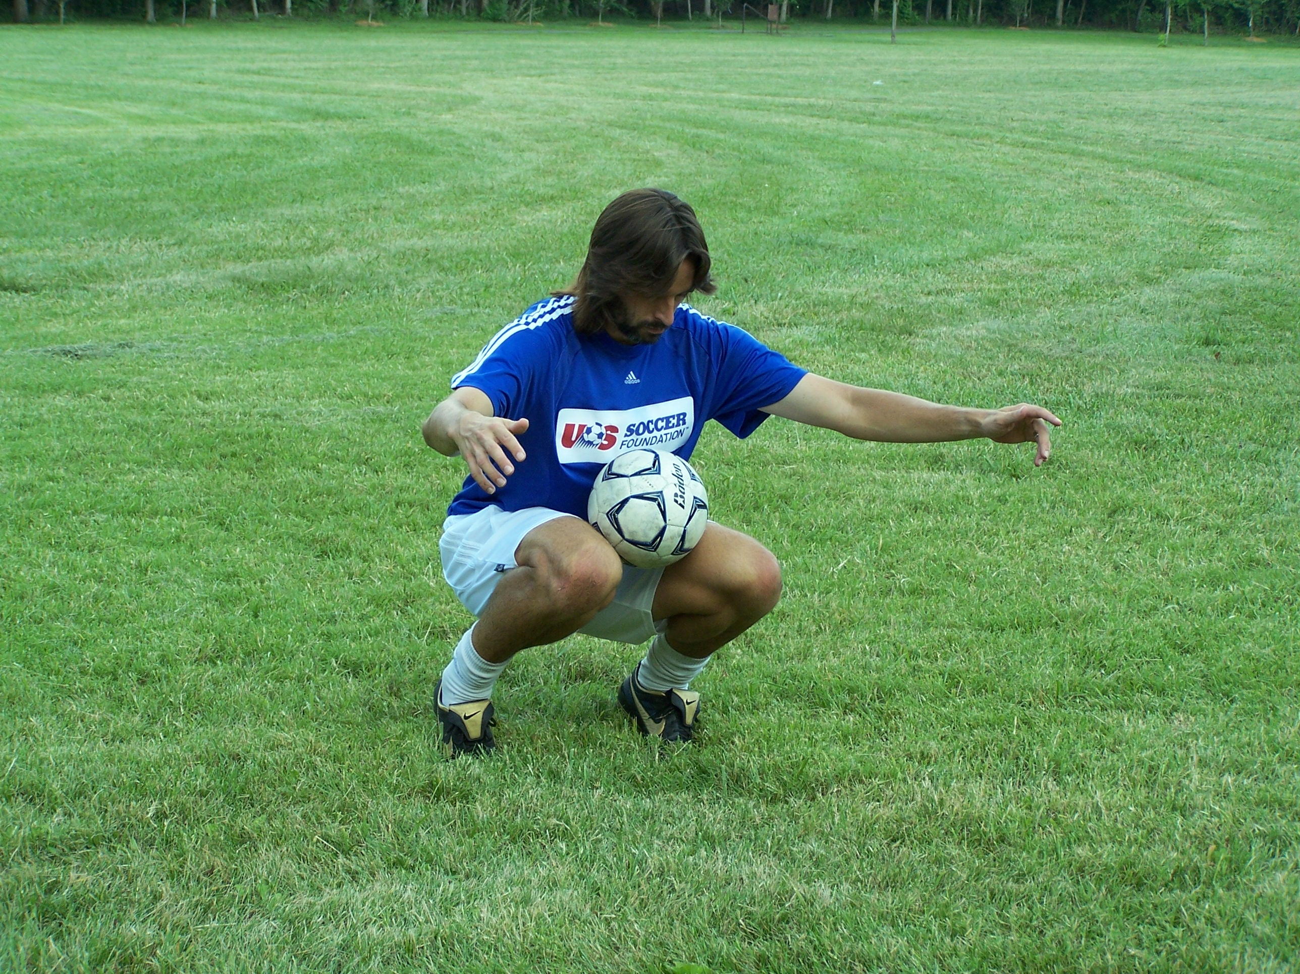
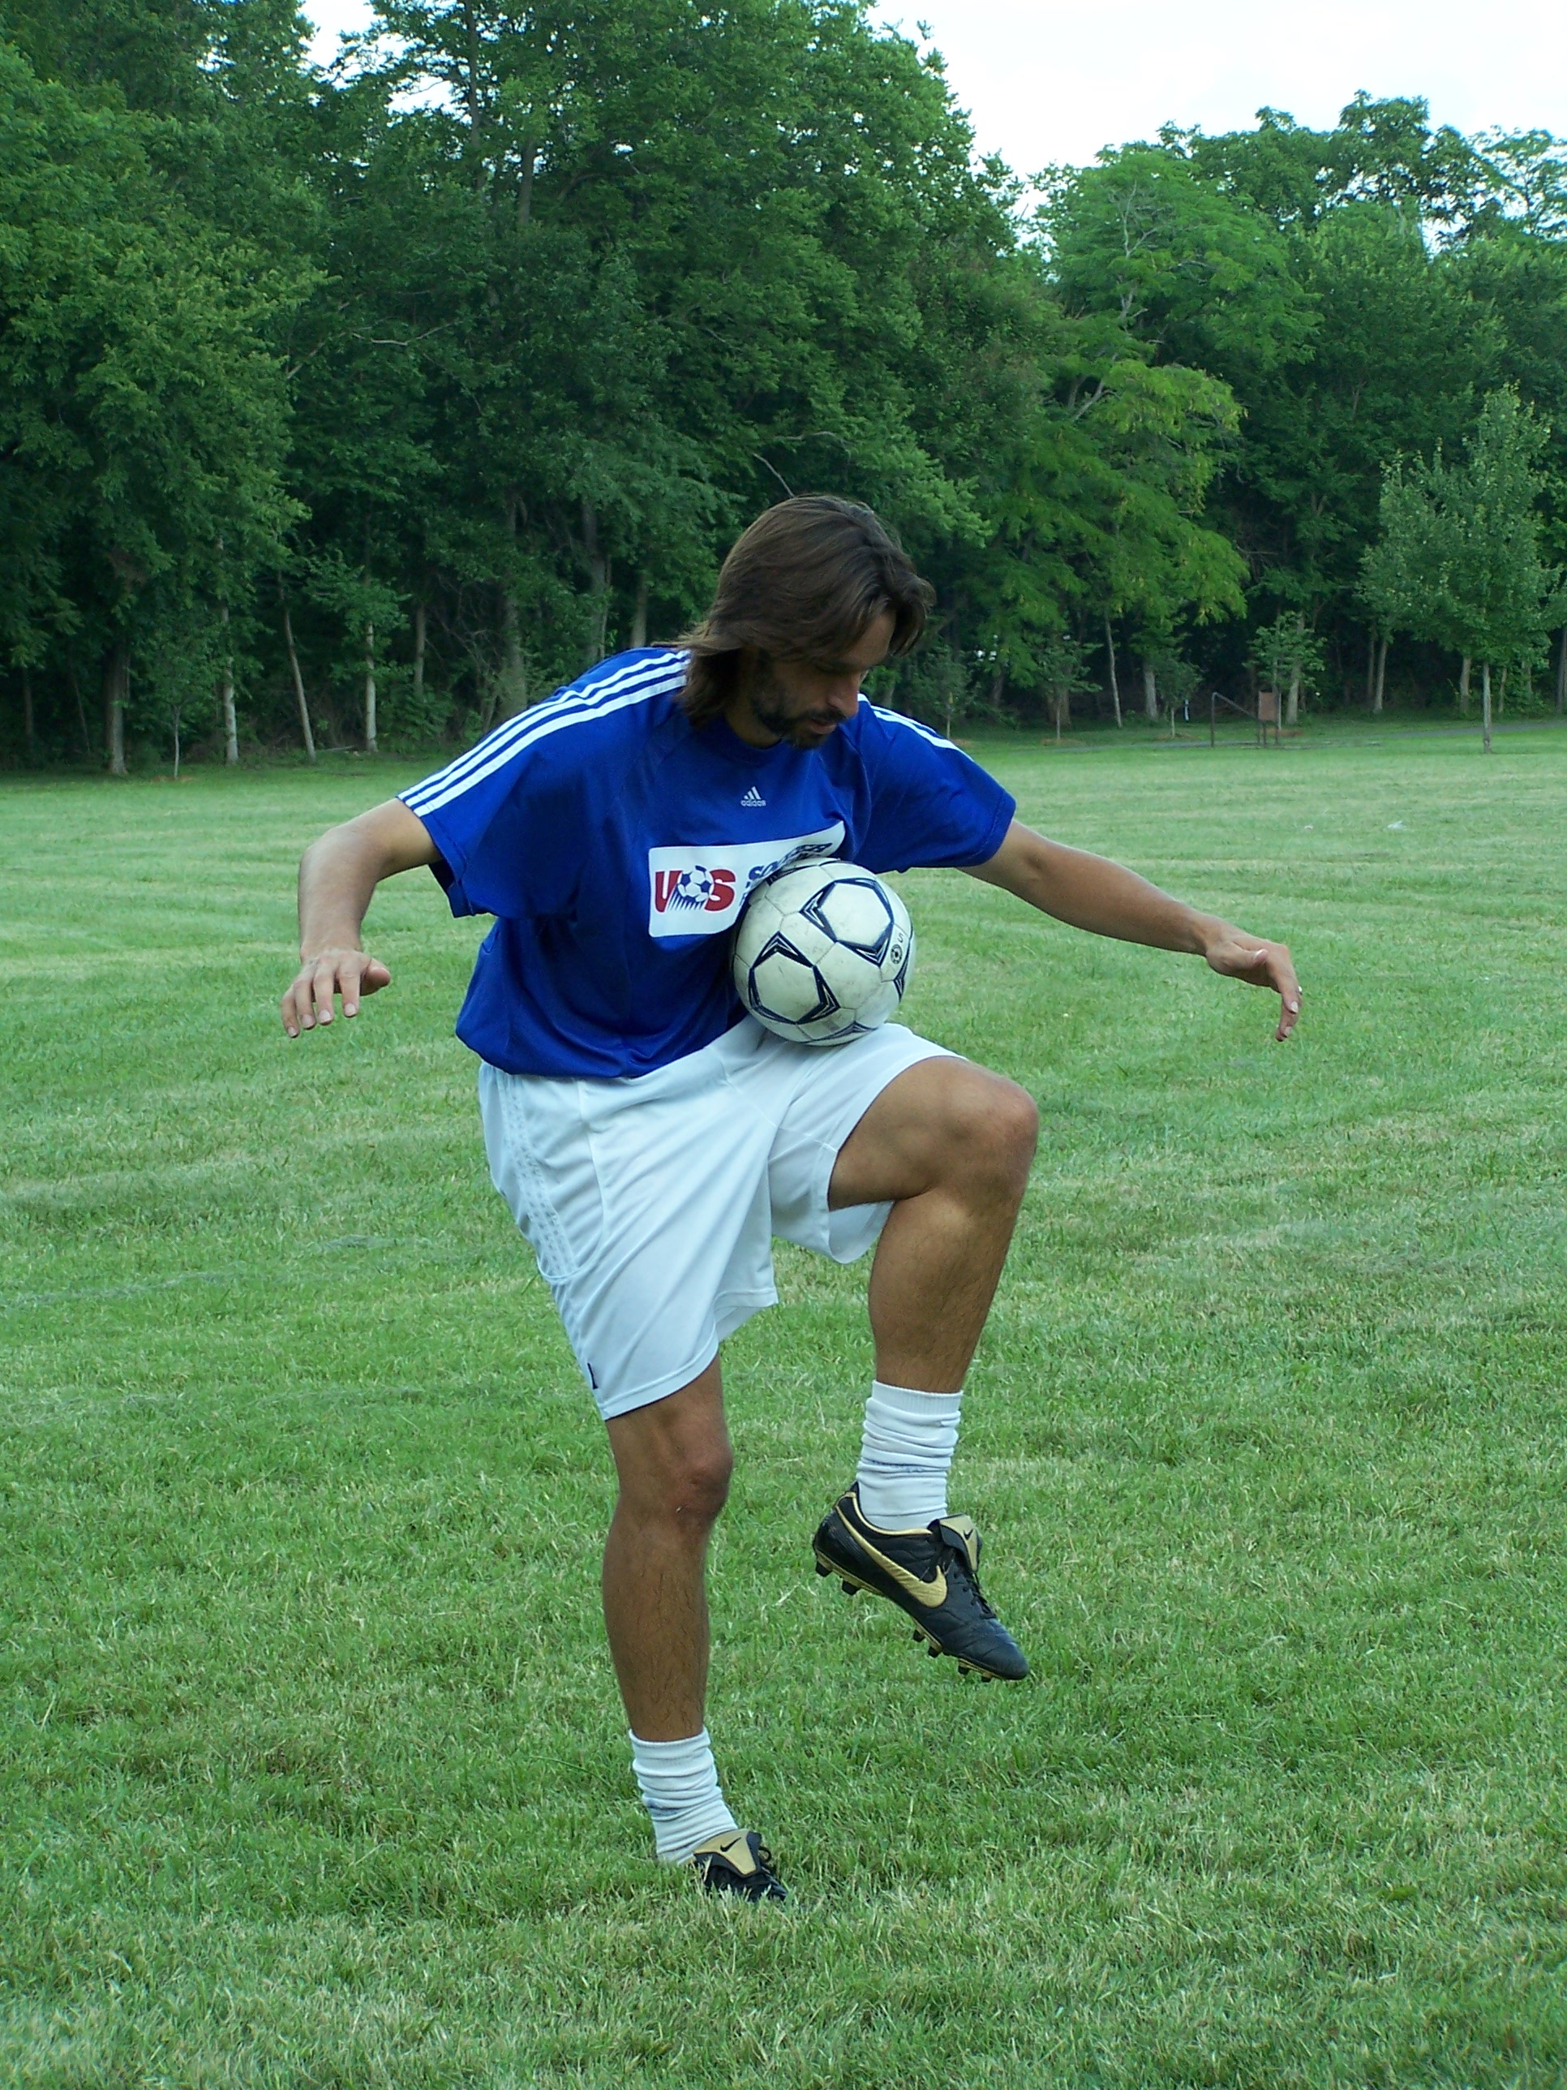
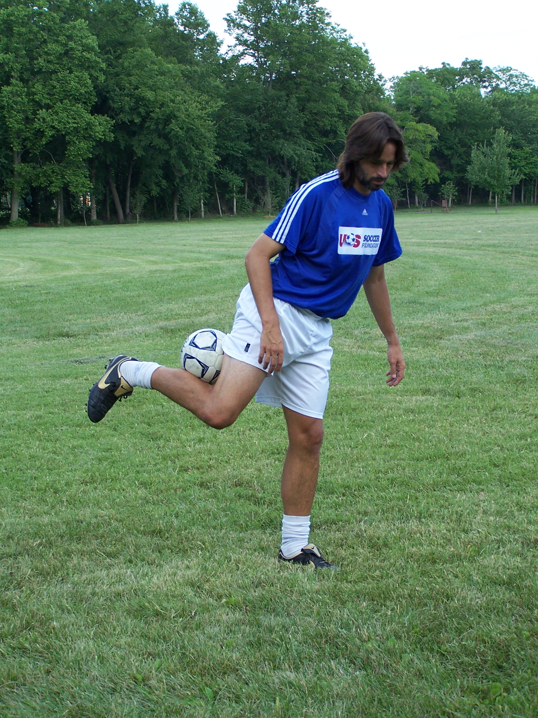

Chicken Wing

Chest/Thigh Trap

LEVEL 8

From Ground
- Right foot stall, left foot stall, knee trap
- Right foot stall, Knee Trap, Ankle trap
- Left foot stall, chest stall, right foot stall
- Ankle trap, Knee trap, lace, head stall
- Right lace, lap stall, left lace, lap stall
- Foot stall, outside of foot stall
- Foot stall, Chicken wing
- Foot stall, thigh/chest trap
- Foot stall, neck stall
- Foot stall, Flamingo
- Foot stall, head stall, Kiss stall
- Foot stall, head stall, neck stall, push up, back stall
- Any 3 in combination
- Any 5 in combination
- Any 7 in combination
- Any 9 in combination
- Any 12 in combination
- Set a new personal juggling record

"One year, I played 15 months”

Franz Beckenbauer

LEVEL 9

Spinning

When a ball comes to you in a game, it usually is spinning -- sometimes slow, sometimes way too fast. Whichever it is, you have to be comfortable receiving it and making it do what you want. So what better way to master a spinning ball than by making it spin on purpose! You control the ball, not the other way around!

So there are 4 basic ways a ball can spin.

      - Front spin (also called topspin)- away from you.
      - Backspin- towards you.
      - Left to right spin
      - Right to left spin.

Now, there are combinations of backspin w/ left to right, front spin w/ right to left, etc. But we are going to just take these basic ones and practice spinning the ball on purpose.

For all these we will be talking about hitting the bottom of the ball.

Some you may find easier than others, especially the backspin, since that already may be the way you juggle on your laces.

Maradona used to warm up before a game by spinning the ball as hard as he could while juggling. He would start the ball low, making it spin right to left. He would then hit the ball higher and higher making it spin every time, till he was knocking it 20 feet in the air. Then, as the ball dropped one last time, he would STALL it on his KNEE!! Just killed it dead from 20 feet out of the air. Artist!

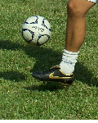
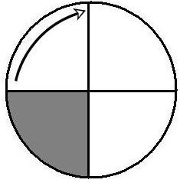
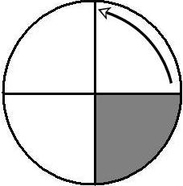

Side View
Side View
Putting front (top) spin the ball is the most difficult. This is used mostly in free kicks to make the ball dip downward after clearing the wall.
To put backspin on a ball, you need to juggle on your laces closer to your toe so that you are hitting the farthest part of the ball first, as in above.

The two below are as if you were standing behind the ball. To spin left to right or right to left, you need to hit the ball on the far side of where you want to go.

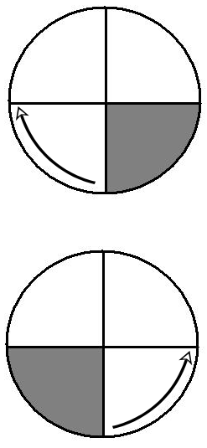

For left to right, hit the right underside and follow through to the left.
Back View

For right to left, hit the left underside and follow through to the right.

LEVEL 9

From Ground
      - Right Lace backspin 2x, Left Lace Backspin 2x
      - Right lace, left to right spin 2x
      - Left Lace, right to left spin 2x
      - Right lace, right to left spin 2x
      - Left lace, left to right spin 2x
      - Right outside, any spin 2x
      - Left outside, any spin 2x
      - Right inside, any spin 2x
      - Left inside, any spin 2x
      - Right lace, Right thigh any spin, right lace
      - Left lace, Left thigh any spin, Left lace
      - Left lace, Left shoulder 2x any spin, Left lace
      - Right lace, Right shoulder 2x any spin, Right lace
      - Laces, Head backspin 3x, Laces
      - Laces, Head sidespin 3x, lace
      - Right lace backspin 5x, Left lace backspin 5x
      - Right lace, left to right spin 5x
      - Left Lace, right to left spin 5x
      - Right lace, right to left spin 5x
      - Left lace, left to right spin 5x
      - Right lace backspin, Left lace backspin, 10x back and forth
      - Left lace Right to left, right lace left to right, 5x back and forth

“I couldn't settle in Italy - it was like living in a foreign country.”

- Ian Rush

LEVEL 10

Joggling

Joggling is juggling while walking forward at first, but eventually jogging. Once the ball is in the air from the surface you are using, start moving forward while keeping the ball up.

Your touch and control has developed enough to this point that you need to stretch yourself. Up till now, the only movement that we have done has been sitting and standing and turning in a circle, none of which require us to move out of one area. In a game you are moving all the time! How often is a team just going to let you stand there and receive the ball. Not very often!! You will be moving the ball and probably receiving it while under pressure.

You will find your own rhythm as you practice joggling. What I have found to work best is juggling on one leg only with backspin (good thing we just worked on that!). I seem to be able to go the fastest and smoothest that way. You may like both feet, which is fine. Just find your own rhythm and use it.

On the next page you will find the world records for joggling (although one was in a car so that doesn’t really count). If Abrahm Munoz can do joggling while going up and down stairs for over an hour, then I think you can start out with a few yards on flat ground. Take a shot. Who knows? Maybe you will be the one to beat his records!

World Joggling Records

Walking while heading a soccer ball: Agim Agushi (Kosovo) covered 15.356 km (9 mi 857 yd) in 3:12:39 hrs on 27 Oct 2002 in Munich (Germany)

Running marathon while keeping up a soccer ball: Dr. Jan Skorkovský (TCH) covered 42.195 km 26 mi 385 yd for the Prague City Marathon on 8 July 1990 in 7:18:55 hrs.

Running half marathon while keeping up a soccer ball: Uno Lindström (SWE): 2:55:49 hrs on 10 August 1985.

Running 100 m while keeping up a soccer ball: Manfred Wagner (SUI): 15.9 sec on 14 July 1996 at the 2nd Rekord-Klub SAXONIA record festival in Flensburg

Running 200 m while keeping up a soccer ball: Abraham Munoz (USA) 40.26 sec on 29 Oct 2000 in Wheaton College, Illinois, USA

Running 1000 m while keeping up a soccer ball: Josef Lochman (TCH): 5:03 min in 1986 in Valasské Mezirící

Running 5000 m while keeping up a soccer ball: Krishnan Kumaravelu (IND) 32:52 minutes on 26 February 2006
Running 1 hour while keeping up a soccer ball: Josef Lochman (TCH): 8680 m (5 mi 693 yd) in 1986 in Valasské Mezirící

Keeping a soccer ball airborne while climbing up a ladder: Paul Sahli (SUI): 111 steps, 8 September 2002 in Oensingen

Running up and down stairs while juggling a soccer ball (with feet and head): Abraham Munoz (USA) 2754 steps walking upstairs as well as downstairs in 1:19 hrs on 28 December 2002 in Morelia Mich.

Running up and down stairs while heading a soccer ball: Agim Agushi (Kosovo) 1920 steps walking upstairs,1860 steps walking downstairs in 1:12:41 hrs on 2 August 2002 in the PTK Building in Prishtina

LEVEL 10

From Ground
- Laces walking 5 yards
- Head walking 5 yards
- Laces jogging 5 yards
- Head jogging 5 yards
- Laces walking 10 yards
- Head walking 10 yards
- Laces jogging 15 yards
- Head jogging 15 yards
- Laces jogging 15 yards, turn, come back to start. No drop.
- Head jogging 15 yards, turn, come back to start. No drop.
- Laces jogging 50 yards
- Head jogging 50 yards
- Laces jogging 50 yards turn, come back to start. No drop
- Head jogging 50 yards turn, come back to start. No drop
- Laces jogging 100 yards, turn come back to start. No drop
- Head jogging 100 yards, turn come back to start. No drop
- Set a new personal juggling record

"There's no in between - you're either good or bad. We were in between." Gary Lineker

LEVEL 11

Speed Juggling

Speed Juggling is juggling the ball as fast as you can under control in a short amount of time. This forces players to react quickly and under control with great touch. The object is to juggle a soccer ball on the foot as many times as possible in thirty seconds or one minute. This method puts you under greater stress and requires immense concentration, which is directly reflected in the fast paced game of today’s top players.

The Guinness Book of World records for speed juggling (at the time of this printing):

Boys Record

144 touches in 30 seconds: Tim Crowe
266 touches in 60 seconds: Ferdie Ato Adoboe

Girls Record

137 in 30 seconds: Tasha Nicole Terani
269 in 60 seconds: Tasha Nicole Terani

Record for most Head Juggles in 60 seconds

Erick Hernandez: 319

Tips and Technique
- Start by placing the ball on your favorite foot and hold it there for a few seconds (foot stall).
- Foot must be angled slightly upward so that the ball can sit on it.
- Squeeze toes together to form a flat surface.
- Ball must be on the laces, but towards the end of the foot
- Start the ball by lifting the knee up slightly.
- Do not strike the ball. Tap it.
- The ball must stay low. If the ball is going above the knee, then it is too high. It should only go an inch or two above the foot.
- Only use one foot and balance on the other leg.
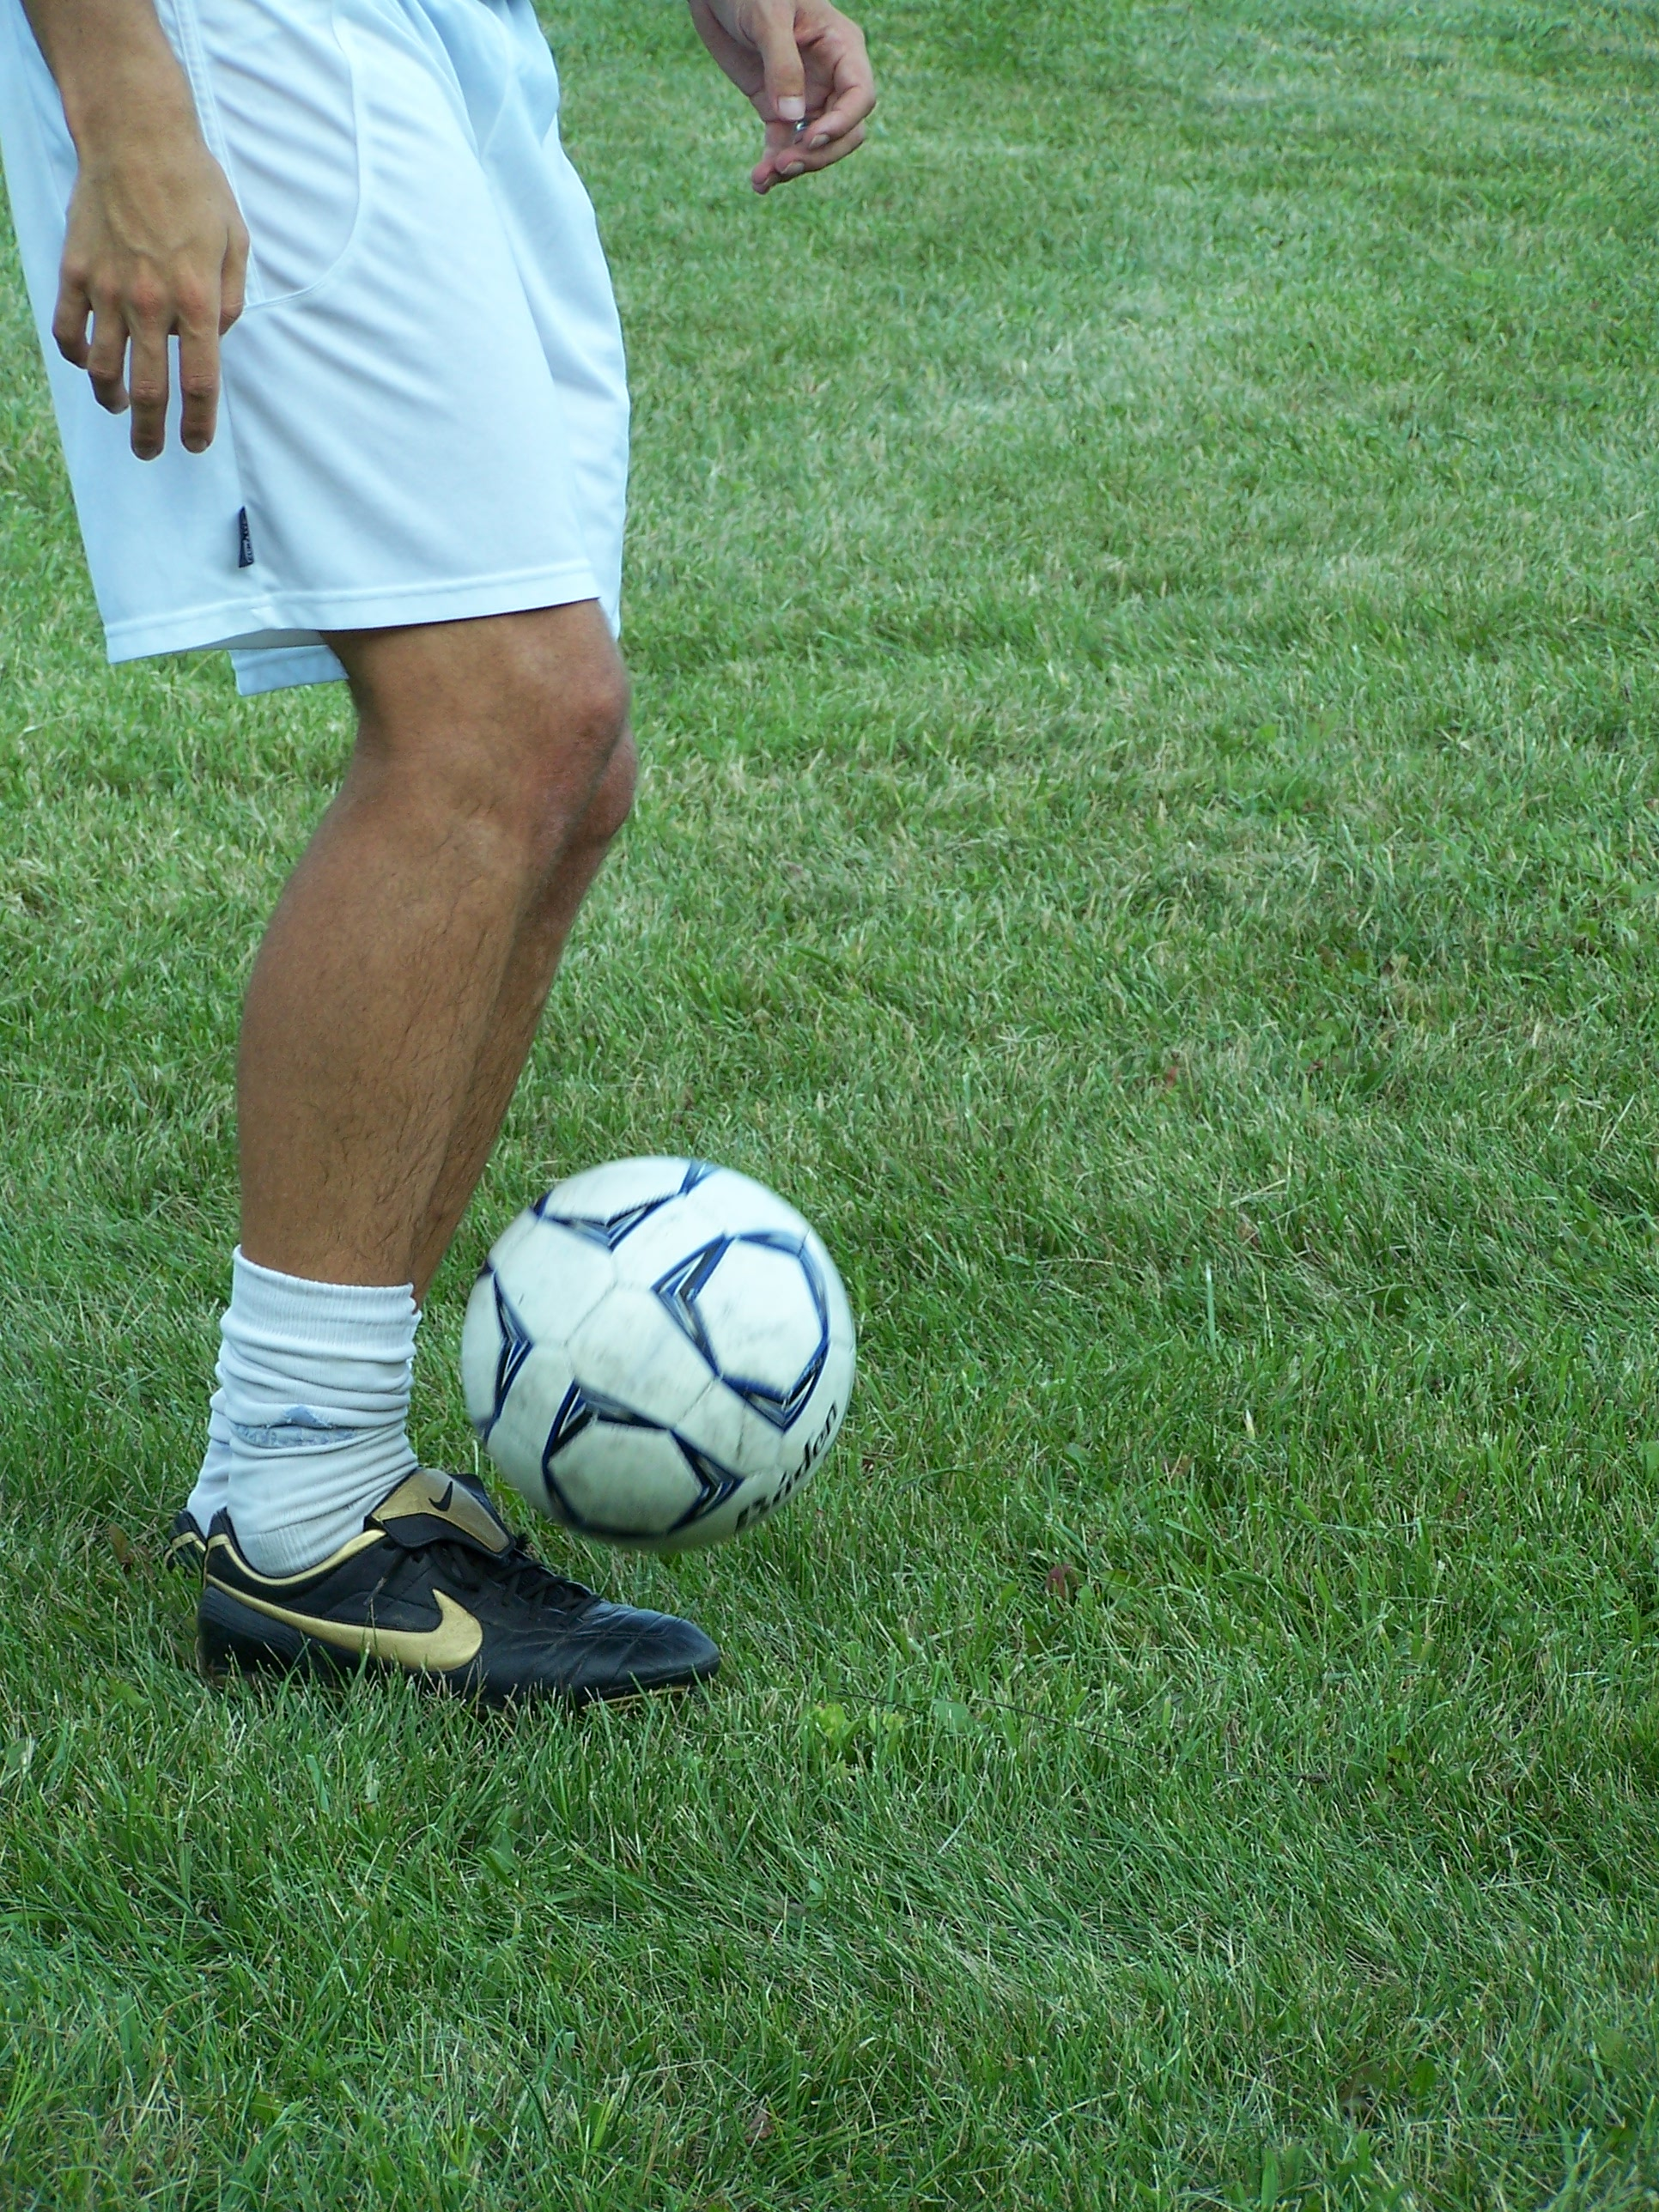

Level 11

- 5 touches in 5 seconds
- 10 touches 10 seconds
- 20 touches 20 seconds
- 30 touches 30 seconds
- 40 touches 60 seconds
- 20 touches 15 seconds
- 30 touches 25 seconds
- 40 touches 30 seconds
- 75 touches 45 seconds
- 100 touches 60 seconds

As you can see by the world records, this level can be taken as far as you want!! Take a shot at the world record! But whatever you do, set your own goal for 30 seconds and for a minute, then beat it!

This is one of the best things in this program to continue to work on, because it will stretch you and always be pushing you to get better. It will force you to focus and react very quickly while under pressure, just like in a game.
“I would have given my right arm to be a pianist”
–Bobby Robson

LEVEL 12

The Bag O’ Tricks

A combination is a sequence of individual skills put together to form one long string of skills. It could be as simple as pullback-foot stall-kick up to head. Or as complicated as this:

- Scoop to foot stall
- Throw from foot stall to head stall,
- From head stall roll down and kiss it and back to head stall,
- Head stall to neck stall,
- In neck stall go down and do a push up,
- In push-up position roll ball to middle of back for back stall
- Roll back to neck stall,
- Stand up
- Throw from neck stall to knees trap
- Pass to chicken wing (thigh-calf trap)
- Extend the leg back, then use your heel to knock the ball over your head back to the front. (Yes, this can be done)

Once you can do each trick by itself, start putting them together one by one. Then make up your own! Remember you can only build a wall one trick….err…. brick at a time….

HAVE FUN!!

"I'm as happy as I can be - but I have been happier."
Ugo Ehiogu

LIFTS

Pullback- Grab the ball with the sole of your foot, roll it back and slide your big toe right down the middle of the ball and pick it up.

Scoop- Put one foot behind the ball with the big toe pointed down the middle of the ball. Step past the ball with the other foot and scoop the ball upward and into the air.

Pinch – Put the ball between your feet with your big toes directly to each side of the ball. Snap your feet together (DO NOT JUMP) and the ball will pop into the air.

Jump- Grab the ball between your heels, jump, bring your knees up and throw the ball forward into the air.

Jump Side/Back- Grab ball between your heels. Kick your heels behind or to the side and release the ball upward into the air.

Outside scoop with roll- With the ball away at 45degree angle, grab the ball with the bottom of the foot and roll towards you, quickly slide the same foot under the ball and lift.

Switch pullback- Same as the pullback, but pull it with one foot and slide the other foot under to pick it up.

Step on and backspin- Stomp on the back of the ball with the front of your foot, the ball will spin backwards. Allow it to roll up your foot and kick it into the air

Stamp- With the inside of your heel stomp on the back or side of the ball hard and straight down. The ball will jump into the air.

Kickstart- One foot behind the ball, just off center. With the heel of the other foot, reach out and kick the ball back into the toe of the other foot. Ball will pop up.

More Juggling World Records

- Football (soccer ball) control: Nikolai Kutsenko (UKR) juggled a regulation soccer ball for 24:30 hrs nonstop with feet, legs and head, without the ball ever touching the ground, on 6 Dec 1995 at Kiev. (see photo) RECORD STATISTICS
- Football (soccer ball) control in a sitting position: Kenneth Yoga (KEN): 4:30:43 hrs on 26 May 2006.
- Football (soccer ball) control in a recumbent position: Tomas Lundman (Sweden) 11:49 minutes on 27 November 2008
- Football (soccer ball) control with the soles: 6:38 min by Jeremy Lynch (GBR) on 29 November 2008 in London VIDEO
- Walking while keeping up a soccer ball: Ricardo Silva Neves (BRA) covered 721 km (448 mi) in June 1992. He arrived in Brasilia after travelling for 12 days.
- Walking while keeping up a soccer ball, non-stop record: Dan Magness (GBR), 48 km [30 miles] on 26 January 2010 in London
- Walking while keeping up a soccer ball, team record: A team from Aubigny (FRA) covered 113 km (70 mi 400 yd) in 11:32 hrs.
- Walking while heading a soccer ball: Agim Agushi (KOS) covered 15.356 km (9 mi 857 yd) in 3:12:39 hrs on 27 Oct 2002 in Munich (Germany)
- Walking backwards while heading a soccer ball: Agim Agushi (KOS), 4220 m on 31 May 2014 in Gjakova (Kosovo) VIDEO
- Walking while balancing a soccer ball on the head: Abdul Halim (BAN), 15.2 km (9.4 mi) on 22 October 2011 at Bangabandhu National Stadium in Dhaka, Bangladesh.
(new record claim, not yet confirmed: 45.64 km by Naib Subedar Azad Singh (IND) on 16 December 2014)
- Running marathon while keeping up a soccer ball: Dr. Jan Skorkovský (TCH) covered 42.195 km (26 mi 385 yd) for the Prague City Marathon on 8 July 1990 in 7:18:55 hrs.
- Running half marathon while keeping up a soccer ball: Uno Lindström (SWE): 2:55:49 hrs on 10 August 1985.
- Running 100 m while keeping up a soccer ball: Manfred Wagner (SUI): 15.9 sec on 14 July 1996 at the 2nd Rekord-Klub SAXONIA record festival in Flensburg (Germany)
- Running 100 m while keeping up a soccer ball on the thigs: Krishnan Kumaravelu (IND): 26.4 seconds on 12 December 2015 in Pattukkottai, India
- Running 100 m while heading a soccer ball: Krishnan Kumaravelu (IND): 21.20 seconds on 15 December 2013 in Madurai, Tamil Nadu, India.
- Running 100 m while balancing a soccer ball on the head: 18.53 seconds, Daniel Cutting (GBR) on 26 February 2011 during halftime of a match between MK Dons F.C. and Brighton and Hove Albion Athletic F.C. in Milton Keynes.
- Running 200 m while keeping up a soccer ball: Abraham Muñoz (USA) 40.26 sec on 29 Oct 2000 in Wheaton College, Illinois, USA
- Running 200 m while heading a soccer ball: Krishnan Kumaravelu (IND): 54.09 seconds on 15 December 2013 in Madurai, Tamil Nadu, India.
- Running 400 m while heading a soccer ball: Krishnan Kumaravelu (IND):1:47 min on 12 December 2015 in Pattukkottai, India
- Running 1000 m while keeping up a soccer ball: Abraham Muñoz (USA) 4:41 min on 30 May 2009 in San Marcos, California, USA
- Running 1000 m while heading a soccer ball: Agim Agushi (Kosovo) 8:50.4 minutes on 13 November 2015 at the Impossibility Challenger Games in Berlin, Germany.
Running 5000 m while keeping up a soccer ball: Krishnan Kumaravelu (IND) 32:52 minutes on 26 February 2006
- Running 1 hour while keeping up a soccer ball: Josef Lochman (TCH): 8680 m (5 mi 693 yd) in 1986 in Valasské Mezirící
- Heading a soccer ball: Tomas Lundman (SWE) 8:32:03 hr at the Gångsatrahallen, Lidingo, Sweden, on 27 February 2004
- Heading a soccer ball, doubles passing: Agim Agushi and Bujar Ajeti (Kosovo) 11,111 times in 3:55:20 hrs on 9 Nov 2003 in Starnberg (Germany) VIDEO (AVI, 4 MB)
- Heading a soccer ball in a sitting position: The three top-performances in this category are very close:
4:09:26 hrs | Tomas Lundman (SWE) | on 20 April 2007 in Märsta, Sweden
4:04:45 hrs | Willis Yoga (KEN) | on 20 November 2008 at the Parklands Sports Club in Nairobi, Kenya
4:02:01 hrs | Agim Agushi (Kosovo) | on 14 August 2005 in Flensburg, Germany

- Longest distance driven in a car (with open roof) while heading the ball: Agim Agushi (Kosovo), 7.1 km on 16 April 2016 in Shkodra, Albania
- Longest distance driven as a co-driver on a moving motorbike: Kenneth Yoga (Kenya) 25:53 minutes (at a speed fo 3.3 km/h) on 20 November 2008 at the Parklands Sports Club in Nairobi, Kenya
- Longest distance driven as a driver on a moving motorbike while balancing the ball on the head: Manoj Mishra (India), from Chandaneswar, Odisha to Pichabani, West Bengal (ca. 30 km) on 5 February 2013
- Keeping a soccer ball airborne while climbing up a ladder: Paul Sahli (SUI): 111 steps, 8 September 2002 in Oensingen (PHOTO)
- Running up and down stairs while heading a football: Agim Agushi (Kosovo) ran up and down 5304 stairs while heading a football in 1:37:05 hours on 31 May 2010. He ascended and descended the 59 storeys of the Messeturm in Frankfurt, Germany two times. He set another record when running up backwards 2040 stairs on Princess Tower, Dubai Marina, Dubai while heading a football on 26 October 2014.
- Balancing (not juggling!) a soccer ball on the head: 14 hours, Manoj Mishra (India) 8 March 2009 in Andul, Howrah (India) (DETAILS)
- Balancing (not juggling!) a soccer ball on a foot: 25:30 minutes, Gidon Fox (South Africa), 23 October 2012 in Johannesburg (South Africa) (DETAILS)
- Balancing (not juggling!) a soccer ball on the head and walking: Abdul Halim (Bangladesh) covered a distance of 15.2 km [9.4 mi] on 22 October 2011 in Dhaka.

Medicine Ball
- Juggling a medicine ball weighting 3 kg ball with feet: Paul Sahli (SUI): 8107 kicks in 1:06:55 hrs on 16 July 1995 in Lostorf
- Juggling a medicine ball weighting 5 kg ball with feet: Conny Strömberg (SWE): 234 kicks in 1:34 min on 27 November 2001 in Stockholm.

Tennis Ball
- Juggling a tennis ball with feet: Jacek Guzowski (POL) 5:28:59 h, 11 Nov 1999
- Heading a tennis ball: Tomas Lundman (SWE) 1:01:02 hrs on 27 Aug 2006 in Stockholm
- Running while keeping up a tennis ball: Dr. Jan Skorkovský
- CH), 11.5 km 7 mi 250 yd in 1:56:36 hrs, 1989
- Running 100 m while keeping up a tennis ball: Josef Lochman (TCH): 23.6 sec, 1986 in Valasské Mezirící
- Running 200 m while keeping up a tennis ball: Josef Lochman (TCH): 56.1 sec, 1986 in Valasské Mezirící
- Running 1000 m while keeping up a tennis ball: Josef Lochman (TCH): 6:51 min, 1986 in Valasské Mezirící
- Keeping a tennis ball airborne while climbing up a ladder: Paul Sahli (SUI): 53 steps, 21 March 2008 at Stade de Genève, Lancy

Handball
- Juggling a handball ball with feet: 3:06:24 hrs, Haruna Abdulazeez (NGR), 22 January 2009 at Sabon Gari, Kano, Nigeria

Billiard Ball
- Juggling a billiard ball with feet: 1:03:21 hrs. Haruna Abdulazeez (NGA), 9 January 2016 in Kano, Nigeria

Swiss Ball
- Keeping up a Swiss ball:1453, Daniel Cutting (GBR) at Klick Fitness Stoke, December 2011 VIDEO

Table Tennis Ball
- Juggling a table tennis ball with feet: Dr. Jan Skorkovský (TCH): 3332 kicks, 1988
- Walking with a table tennis ball balanced on the head: Dr. Jan Skorkovský (TCH) 3.3 km 2 mi 90 yd in 34:36 min on 6 April 1991 in Zurich

